
A Project Report on
AI-Powered-Marketing-Content-Generation
Submitted partial fulfilment for award of degree of
Master of Science
In Artificial Intelligence

Submitted by
Shyam Sundar K
R22MSA55

Under the Guidance of
Yuvaraj M
Senior Manager, Data Science
Comcast India

REVA Academy for Corporate Excellence
REVA University
Rukmini Knowledge Park, Kattigenahalli,
Yelahanka, Bangalore – 560064

August, 2026

Candidate’s Declaration
I, Shyam Sundar K hereby declare that I have completed the project work towards the Master of Science in Artificial Intelligence at, REVA University on the topic entitled AI-Powered-Marketing-Content-Generation under the supervision of Yuvaraju M This report embodies the original work done by me in partial fulfilment of the requirements for the award of the degree for the academic year 2026.

Place: Bengaluru Name of the Student: Shyam Sundar K

Date: 22/08/2026 Signature of Student:

Acknowledgment of Project Ownership and Usage Rights
I, Shyam Sundar K, a student enrolled in the Master of Science Program and 2026 Year at RACE, hereby acknowledge that any project, including but not limited to software, hardware, research, or other intellectual property created by me during my academic tenure at RACE, is the property of RACE, REVA University.
I understand and agree that RACE has the exclusive rights to use, reproduce, modify, or distribute the aforementioned projects for academic, research, and further development purposes. This includes the right to monetize, commercialize, or otherwise exploit the projects as deemed fit by RACE.
I acknowledge that I have no objection to RACE, REVA University, using, reproducing, or further developing the projects for the benefit of the institution and its academic community. I further affirm that any commercial or research activities related to the projects conducted by RACE shall not require additional consent or approval from me.
This acknowledgment is made willingly and without any reservations. I am grateful for the education and opportunities provided by RACE, and I recognize the importance of contributing to the academic and research goals of the institution.

Place: Bengaluru Name of the Student: Shyam Sundar K
Date: 22/08/2026 Signature of Student:

Certificate

This is to certify that the project work entitled AI-Powered-Marketing-Content-Generation has been carried out by Shyam Sundar K with SRN R22MSA55, who is a bonafide student of REVA University, is submitting the first year project report in fulfilment for the award of Master of Science in Artificial Intelligence during the academic year 2026. The Project report has been tested for plagiarism, and has passed the plagiarism test with the similarity score less than 15%. The project report has been approved as it satisfies the academic requirements in respect of the project work prescribed for the said degree.

Signature of the Guide Signature of the Director
Dr. JB Simha Dr. Shinu Abhi
Guide Director

External Viva
Names of the Examiners
- <Name> <Designation> <Signature>
- <Name> <Designation> <Signature>

Place: Bengaluru
Date: 22/08/2026

Acknowledgement
I express my deepest gratitude to my mentors and trainers for their invaluable guidance, insights, and encouragement throughout this project. In particular, I sincerely thank Dr. Shinu - Director, Yuvaraju M Senior Manager, Data Science, Comcast India ,Mentor and Dr. Rashmi for their expert advice, continuous support, and motivation. Their mentorship has been instrumental in shaping my understanding and enhancing my problem-solving abilities.
I extend my heartfelt appreciation to my classmates and program office members for their constructive discussions, collaboration, and support, which have contributed significantly to the successful completion of this work. I am also deeply grateful to my family and friends for their unwavering encouragement, patience, and belief in me throughout this journey.
Furthermore, I would like to by the Hon’ble Chancellor, Dr. P Shayma Raju, Hon’ble Vice Chancellor, Dr. Sanjay Chitnis, and Registrar, Dr. M. Dhanamjaya. Their leadership, vision, and commitment to academic excellence have created an environment that fosters innovation and research
Lastly, I extend my gratitude to everyone who has directly or indirectly contributed to this project. Their support and encouragement have been invaluable in completing this work successfully.

Place: Bengaluru
Date: 22/08/2025

Similarity Index Report

This is to certify that this project report titled AI-Powered-Marketing-Content-Generation was scanned for similarity detection. The process and outcome are given below. The plagiarism report is attached in the appendix.

Software Used: Turnitin
Date of Report Generation:
Similarity Index in %:
Total word count:
Name of the Guide: Yuvaraju M

Place: Bengaluru Name of the Student: Shyam Sundar K
Date:22/08/2026 Signature of Student

Verified by:

Signature
Dr. Shinu Abhi,
Director, Corporate Training

AI Usage Disclosure Statement
This is to certify that the project report titled "titled AI-Powered-Marketing-Content-Generation" has been prepared in accordance with the academic integrity guidelines of REVA Academy for Corporate Excellence (RACE), REVA University.
AI Tool Usage Details
AI Tool(s) Used (if any): Chat GPT, Claude
Version / Model: GPT 5.3 , Sonnet 5, Opus 5.
Purpose of AI Usage: Grammar/Language, Structuring, Code, Data Analysis, Literature Search, Image Generation, Other
Approximate AI Contribution ___________%
Student Declaration
- Artificial Intelligence (AI) tools, if used, were employed only as assistive technologies during the preparation of this project report.
- All research objectives, methodology, implementation, analysis, results, discussions, conclusions, and recommendations are my/our own original work.
- I have reviewed, verified, edited, and validated all AI-assisted outputs before including them.
- I take full academic responsibility for the authenticity, accuracy, originality, and ethical use of all content and all external sources, including AI-assisted content where applicable, have been appropriately acknowledged.
Name of Student: Shyam Sundar K Signature of Student:
Verified by: Irshad Ahmed

List of Abbreviations
Abbreviation | Expansion | Abbreviation | Expansion
AAC | Advanced Audio Coding | LLM | Large Language Model
AI | Artificial Intelligence | MP4 | MPEG-4 Part 14 container
API | Application Programming Interface | ONNX | Open Neural Network Exchange
ASCI | Advertising Standards Council of India | PK | Primary Key
CLI | Command-Line Interface | RAG | Retrieval-Augmented Generation
CPU | Central Processing Unit | RAM | Random Access Memory
CRUD | Create, Read, Update, Delete | SHA-1 | Secure Hash Algorithm 1
CTA | Call To Action | SQL | Structured Query Language
DAG | Directed Acyclic Graph | SWOT | Strengths, Weaknesses, Opportunities, Threats
DFD | Data Flow Diagram | TDSP | Team Data Science Process
DOI | Digital Object Identifier | TTS | Text-To-Speech
ER | Entity–Relationship | UI | User Interface
FIFO | First In, First Out | URL | Uniform Resource Locator
FK | Foreign Key | WAL | Write-Ahead Logging
fps | Frames Per Second | WAV | Waveform Audio File Format
HTML | HyperText Markup Language | YAML | YAML Ain't Markup Language
HTTP | HyperText Transfer Protocol | FR / NFR | Functional / Non-Functional Requirement
JSON | JavaScript Object Notation | TC | Test Case

List of Tables
Table No. | Title | Page No.
Table 3.1 | Stakeholder map | 18
Table 4.1 | Objective Mapping | 21
Table 5.1 | Problems encountered and how the approach changed | 23
Table 6.1 | Hardware Requirements | 25
Table 6.2 | Software Requirements | 25
Table 6.3 | Data Requirements | 26
Table 7.1 | Design decisions and the alternatives rejected | 32
Table 8.1 | The five generation agents | 34
Table 8.2 | What Is Normalized Locally Versus What Is Rejected and Re-Asked | 38
Table 8.3 | Failure taxonomy and system response | 40
Table 9.1 | Functional requirements | 43
Table 9.2 | Functional Test Cases and Results | 45
Table 9.3 | Recorded job ledger for product #4 (2026-08-06) | 46
Table 9.4 | Traceability of every factual claim in version v1 | 48
Table 9.5 | Estimated Resource Usage per Successful Run | 49
Table 10.1 | Objectives, targets and measured outcomes | 53
Table 10.2 | SWOT analysis of the delivered system | 54
Table 11.1 | Limitations | 57
Table A.1 | Command-line entry points | 62

List of Figures
Figure No. | Title | Page No.
Fig. 1.1 | Scope of the system, one public Shopify product URL in, eight versioned… | 13
Fig. 5.1 | TDSP Methodology | 22
Fig. 7.1 | Layered architecture | 28
Fig. 7.2 | The nine-node pipeline graph | 29
Fig. 7.3 | Level-1 data-flow diagram | 30
Fig. 7.4 | Entity–relationship model | 30
Fig. 7.5 | Request lifecycle | 31
Fig. 7.6 | The brand definition as the single authority for prompts, validation limits… | 32
Fig. 8.1 | The four-stage JSON extraction and repair pipeline | 36
Fig. 8.2 | Code Snippet of Brace Scanner | 37
Fig. 8.3 | Code Snippet of Repair Retry Loop | 39
Fig. 8.4 | The human-in-the-loop review and regeneration loop | 41
Fig. 9.1 | Composition of the automated test suite, by module | 44
Fig. 9.2 | Stage-level wall-clock timing for the successful run, from the application's… | 47
Fig. 9.3 | The timing chain, from the validator's recomputed script duration to the… | 49
Fig. 9.4 | Frames from the five scenes of the rendered video, title, two feature scenes,… | 50
Fig. 10.1 | Attempts required per agent, from the application's log table | 52
Fig. A.1 | Environment setup | 61

Abstract
A small direct-to-consumer retailer selling any catalogue of physical products, gifts, apparel, handmade goods or otherwise, through a Shopify storefront is typical of the target user. Generative models can write that copy, but the failure that matters in marketing is not a clumsy sentence. It is a confident, brand-shaped claim about a specification or price that nobody can trace to a source and that a reviewer may approve because it reads well.
This project addresses the problem of generating marketing content that is not only engaging but also structurally disciplined against unsupported product claims, enforced through prompt constraints, schema validation and a human review gate, while preventing such claims from being accepted or replaced with fallback content.
The system turns a single public Shopify product URL into a complete, reviewable content package, a campaign brief, a five-beat voiceover script and a rendered 1080×1920 H.264 video-a deterministic Ken Burns-style animation over the product's existing photography, not diffusion-generated video footage, with a provenance sidecar recording what produced each artefact. Following the Team Data Science Process, the generation layer is a LangGraph state graph of nine nodes over seven supersteps, with five prompt-driven LLM agents, three running as one parallel superstep joined by explicit state reducers. Every brand rule, tone, vocabulary, personas, content limits, compliance clauses and visual geometry lives in a single machine-readable brand file. Model output is parsed by a hardened JSON extractor, validated against brand-derived schemas and re-asked with the specific violation; a run that still fails is never covered with placeholder copy. A human approve/reject gate closes the loop, carrying reviewer feedback and scope forward.
The implementation is 6,488 lines of application Python across eight packages. End-to-end validation on a live product page produced a complete version within a few minutes, with the narration duration measured from the WAV header matching the rendered MP4 duration exactly. Every factual claim in the demonstrated package was verified to trace to the scraped product record, human review rather than automatic semantic verification
Keywords: Generative AI, Multi-Agent Systems, LangGraph, Marketing Content Generation, Hallucination Mitigation, Schema Validation, Human-in-the-Loop, Short-Form Video, Text-to-Speech, Team Data Science Process.
Table of Contents
Candidate’s Declaration 2
Acknowledgment of Project Ownership and Usage Rights 3
Certificate 4
Acknowledgement 5
Similarity Index Report 6
AI Usage Disclosure Statement 7
List of Abbreviations 8
List of Tables 8
List of Figures 9
Abstract 11
Chapter 1: Introduction 13
Chapter 2: Literature Review 15
Chapter 3: Problem Statement 18
Chapter 4: Objectives of the Study 20
Chapter 5: Project Methodology 22
Chapter 6: Resource Requirement Specification 25
Chapter 7: Software Design 28
Chapter 8: Implementation 34
Chapter 9: Testing and Validation 43
Chapter 10: Analysis and Results 51
Chapter 11: Conclusions and Recommendations for Future Work 56
Bibliography 59
Appendix A: Repository, Setup and Entry Points 61
Appendix B: Plagiarism Report 63

Chapter 1: Introduction
This chapter opens with why short-form vertical video has become the default unit of consumer marketing and where generative models fall short of it, then names the gaps in current tooling that this project responds to, before fixing the scope of the system built to close them.
1.1 Background of the Study
Short-form vertical video has become the default unit of consumer marketing. A brand selling through Instagram Reels or YouTube Shorts does not publish one campaign a quarter, it publishes a clip per product, per variant, per seasonal angle, and revises those clips whenever a reviewer disagrees with the hook. Each clip needs a strategy note, a script written to be spoken, a caption written to survive truncation, a hashtag set, a narration and an edit.
Huang and Rust distinguish mechanical AI that automates repetitive marketing tasks, thinking AI that turns data into decisions, and feeling AI that handles interaction[1]. Generative work long sat outside all three, because models could produce fluent copy but not copy an organisation would put its name on. Grewal et al. argue that generative AI is now reshaping content creation, while stressing that the human augmentation an output requires decides whether the technology is usable at all [2]. E-commerce fits this well because the source facts are already structured et[3].
That failure mode is hallucination: text that is fluent, plausible and unsupported by the source [4]. In a chatbot it is an annoyance. In a marketing asset it is a claim, “45 cm tall”, “hand-finished”, “₹19,999”, that reads exactly like the true claims around it, may be approved by a reviewer with no easy way to check it, and then goes out under the brand's name.
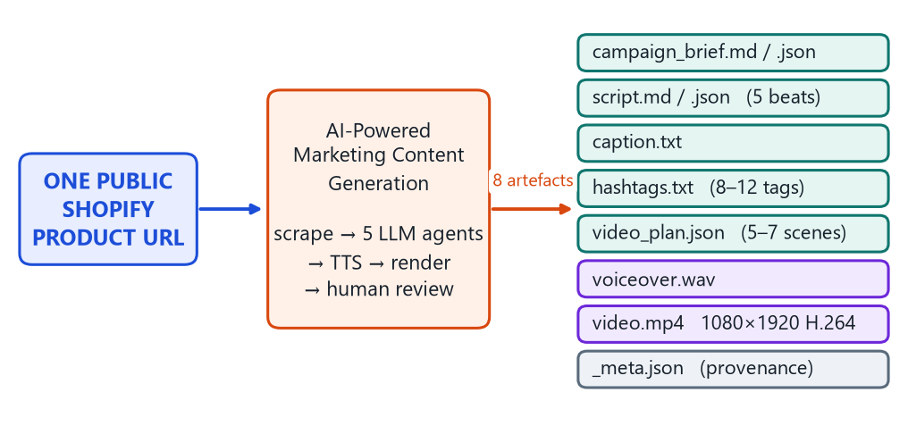
Fig. 1.1: Scope of the System, One Public Shopify Product URL in, Eight Versioned Artefacts Out, With a Human Review Gate in Between.
1.2 Need for the Study
Following are the Three gaps identified that motivates this work.
- Tooling is fragmented: copy comes from one tool, narration from a second, an edit from a third, and nothing carries the product's specification table through all of them, so nothing guarantees that the number spoken in the narration is the number printed on the frame.
- Brand governance is treated as review rather than as constraint: Tone of voice, banned vocabulary, persona targeting and regulatory language usually live in a document someone is expected to have read. Nothing in the generation path enforces them, so every violation must be caught downstream by the reviewer who is already the bottleneck. Under advertising codes such as the ASCI Code, which requires advertisements to be truthful and places the substantiation burden on the advertiser [4], that is a weak control.
- Generative systems in this space are built to always return something: When a model fails they fall back to a template or a cached response, which is defensible for a search box and indefensible for marketing copy, because the fallback is indistinguishable from real output at the point where a human approves it.
1.3 Scope and Potential Impact
The system takes a single public Shopify product URL and produces a complete, reviewable package for one short-form vertical video: a campaign brief, a five-beat voiceover script, an Instagram/Reels caption, a hashtag set, a shot-by-shot video plan, a narration WAV, a rendered 1080×1920 H.264 MP4 (template-driven animation over authoritative product stills), and a provenance sidecar (Fig. 1.1). The brand is a direct-to-consumer Shopify retailer; the pipeline is agnostic to what it sells. Scope is limited to English.
For a catalogue retailer, the marginal cost of a product's first content package drops from a multi-person workflow to a click and a review — one measured end-to-end run completed in 214 seconds on a laptop. The less obvious impact is on trust: every artefact carries a provenance record naming the model that produced it. The approach generalizes to any domain where source facts are structured and copy must not exceed them. Chapter 2 turns to the published work each of these three gaps builds on.

Chapter 2: Literature Review
This chapter reviews the work this project builds on, positioning each contribution and stating what remains unresolved. Section 2.6 consolidates the gap the project addresses.
2.1. Generative AI in Marketing Content Production
Huang and Rust's three-stage framework remains the clearest account of where automation sits in a marketing function [1], its value here is that it names content production as mechanical work worth automating while leaving open how quality is controlled. Grewal et al. observe that the cases which work keep a human on the output rather than only on the prompt [2]. Neither specifies a mechanism by which brand voice or factual constraints are enforced during generation, and neither treats model failure as an engineering event with a defined outcome.
2.2 Generation from Structured E-Commerce Product Data
Chen et al. proposed KOBE, a Transformer generating personalised product descriptions by conditioning on product aspects, user categories and a knowledge base [3]. It establishes that catalogue attributes are a sufficient basis for usable copy, but KOBE is a trained model, so retargeting means retraining, and its output is one artefact rather than a campaign. This project supplies the catalogue to a general-purpose model at inference time and generates five interdependent artefacts whose consistency the pipeline enforces, exploiting the fact that a Shopify product page's .json representation is publicly readable [5].
2.3. Hallucination, Faithfulness and Attribution
Ji et al. give the canonical taxonomy, separating intrinsic hallucination, where output contradicts the source, from extrinsic hallucination, where output cannot be verified against it and conclude that no single technique eliminates hallucination and practical systems must layer several [6]. Maynez et al. supply the result that matters most here: models hallucinate content unfaithful to the input at high rates and overlap metrics such as ROUGE do not detect it [7], so a caption scoring well on fluency says nothing about whether its numbers are real.
Rashkin et al. define Attributable to Identified Sources, a framework in which every claim about the external world must be verifiable against an identified source [8]. The dominant mitigation in practice is retrieval augmentation [9], which assumes a large corpus that must be searched. Here there is exactly one relevant document per product and it is known before generation begins, so the retrieval problem disappears and what remains is the harder problem of ensuring the model does not exceed a source it has already been given.
2.4. Structured Output and Multi-Agent Orchestration
Willard and Louf reformulate constrained generation as transitions in a finite-state machine over the model's vocabulary [10], and Geng et al. reach a similar guarantee through grammar-constrained decoding [11]. Both require access to the token distribution, an assumption that fails for hosted commercial APIs, which is the case here and the common case in industry. The practical alternative is post-hoc: parse defensively, validate against a schema, re-ask with the violation quoted. Liu et al.'s survey supplies the other half of the problem, that the prompt is where task knowledge is injected [12].
On orchestration, ReAct shows that explicit decomposition improves accuracy and interpretability [13], AutoGen generalises this to conversable agents [14], and Guo et al. identify coordination, state management and evaluation as open problems [15]. Conversational frameworks are non-deterministic: the agents decide who speaks next, so the number of model calls is emergent, which for a pipeline whose cost per run is a billing line is the wrong trade. LangGraph offers a compiled state graph with typed shared state and reducers that make concurrent writes safe [16]. Self-Refine shows a model can critique its own output [17], the loop here takes its critique from a deterministic validator instead, giving a bounded loop that cannot talk itself into accepting bad output.
2.5. Media Generation and Human Oversight
Blattmann et al.'s Stable Video Diffusion establishes a training recipe for latent video diffusion [18]. For a product marketing asset, synthesised video is nonetheless the wrong tool, for a reason unrelated to quality: a diffusion model asked to depict a specific product produces a plausible looking one, not that one. The correct problem is animating authoritative stills. This project implements the classical 2D form of the Ken Burns effect [19], [20], because the goal is a deterministic renderer that runs on a laptop CPU, and takes narration from a pluggable chain led by a hosted neural voice, falling back to Piper, which packages VITS-derived voices [20]as ONNX models that run offline [21].
Wu et al. observe that most human-in-the-loop work targets improving model performance rather than governing model output in production [22]. Amershi et al.'s guidelines address the second concern directly: make clear what the system can do and why it did what it did, and support efficient correction [23]. Sculley et al.'s warning that configuration and undeclared consumers are where technical debt accumulates around a model [24] is answered here by fail-fast typed configuration, a brand file with a validated required-key set, and a provenance record naming every consumer of an artefact.
2.6. Research Gap
Four gaps follow, and they are what this project is built to close.
- Grounding is studied as a retrieval or evaluation problem, not as an engineering constraint on a pipeline where the source document is already known.
- Brand governance is treated as human review rather than as machine-readable configuration driving both the prompt and the validator.
- Published systems generate one artefact, nothing addresses the consistency problem when a brief, script, caption, hashtag set and shot plan must all agree about the same product.
- Failure behavior is almost never specified, and scoped feedback, “this part is wrong, the rest is fine”, is not modelled, so one objection costs a full regeneration.
Liu et al.'s G-Eval shows a strong model can score generated text in reasonable agreement with human judgement [25], but it was not adopted here because an LLM judge assesses quality, whereas the property this system guarantees are groundedness.
Those four gaps, grounding treated as retrieval rather than as an engineering constraint, brand governance left to human review, single-artefact generation, and unspecified failure behaviour, are what Chapter 3 turns into a formal problem statement.

Chapter 3: Problem Statement
3.1 Introduction
A small direct-to-consumer retailer of this kind, selling gifts, apparel, handmade goods or any other catalogue of physical products, operates through a Shopify storefront. Each product carries a photographic set, a descriptive body and an HTML specification table listing whatever attributes the catalogue defines, such as size, material, weight or other measurable figures.
Discovery for this category happens on Instagram and YouTube rather than on the storefront, so a product without a vertical clip is invisible to the audience most likely to buy it. The content requirement is therefore not campaign-shaped but catalogue-shaped: it scales with the number of SKUs rather than with the marketing calendar, and every step of the manual chain repeats in full whenever a reviewer objects to any single element.
3.2 Statement of the Problem
Given a single public product URL from a Shopify storefront, produce a complete and internally consistent short-form video marketing package, campaign brief, spoken script, caption, hashtag set, shot plan, narration and rendered vertical video, such that every factual claim is disciplined to trace to the scraped product record through prompt constraints and human review, every element conforms to a machine-readable brand definition, the package is presented to a human for approval with its provenance visible, a rejection carries scoped feedback into the next version without regenerating what the reviewer accepted, and the system fails visibly rather than substituting plausible placeholder content when it cannot meet those conditions.
Table 3.1: Stakeholder Map
Stakeholder | Position in the process | Interest and concern
Marketing reviewer | Approves or rejects every asset before publication | Wants a publishable clip quickly and needs to see at a glance what changed between versions. Is the bottleneck today, and is the person a confident hallucination would deceive.
Brand owner | Defines voice, positioning and permissible claims | Wants tone and banned vocabulary applied consistently across hundreds of assets without personally reading each one.
Product / catalogue team | Maintains the product pages and specification tables | Is the authoritative source of every fact the marketing may state, needs generated copy to track the page when a specification is corrected.
Compliance reviewer | Checks claims against the ASCI Code [4] | Needs each numeric claim traceable to a source and manufacturer-claim disclosures present wherever a headline figure is the main claim.
Engineering / operations | Runs the system | Needs reproducible runs, diagnosable failures, swappable model providers and predictable cost per run.
3.4 Strategic Significance
- It is a cost problem with a compounding shape. The manual chain costs roughly the same for the tenth product as for the first, and revision costs nearly as much as an original, so a retailer cannot expand its catalogue without linearly expanding its marketing team.
- It is a risk problem with an asymmetric payoff. A clumsy sentence costs engagement, an invented specification costs credibility and, under the ASCI Code, exposes the advertiser to a substantiation challenge [4]. Because a hallucinated claim is stylistically indistinguishable from a true one, the risk rises with output volume rather than falling, since review attention per asset falls.
- It is a governance problem that is currently unmodelled. Brand voice exists as prose in a document, and nothing connects that document to what a generation system does. Until the rules are machine-readable, every rule change requires re-educating humans rather than editing a file.

This problem statement, and the stakeholder map and strategic significance behind it, this translates into six objectives, each written so its achievement can be checked against something observable.

Chapter 4: Objectives of the Study
Six objectives define the study. Each names its execution phase, states what will be produced, and is written so that its achievement can be checked against something observable. Section 4.7 maps every objective to the chapter that demonstrates it. Objectives are listed below:
1. To Design a brand-governed, multi-agent software architecture
To build the software architecture for converting a single public Shopify product URL into a complete short-form video marketing package. The design must specify the LangGraph state-graph topology and the point at which independent agents may run concurrently, the typed pipeline state and reducers that make those concurrent writes safe, a six-table relational model in which a version exists only when every artefact behind it is on disk, and a provider-agnostic gateway reaching OpenAI, Gemini, or Anthropic without any node knowing which is active.
2. To Build the end-to-end generation pipeline
A to build shopify scraper that extracts the specification table separately from the descriptive prose, a persistence layer that is also the job queue, five prompt-driven LLM agents producing the brief, script, caption, hashtags and shot plan, a pluggable text-to-speech chain led by a hosted engine with local offline fallbacks, and a deterministic renderer composing a 1080×1920 H.264 video whose duration matches the synthesised narration exactly. Every brand rule must live in a single machine-readable file and nowhere in the Python.
3. To Implement the fact-grounding and validation layer
To build the validation layer that makes an unsupported claim structurally difficult to produce and impossible to publish silently: a hard-fact rule binding every agent to the scraped record, a four-stage hardened JSON extractor, brand-derived schema validators with an explicit split between problems the code may normalize and problems only the model can fix, a repair-retry loop returning the specific violation to the model, and a no-fallback rule under which a run that cannot produce valid content fails rather than substituting placeholder copy.
4. To Test every functional requirement
To test the requirements through an automated suite executing offline, with no API key and no network access, covering response parsing against real-world malformations, every validators accept, normalize and reject paths, scraper behavior, repository and job-lifecycle semantics against a real temporary database, pipeline scoping and timing logic, and both interface pages. Results are to be recorded as executed test cases with outcomes, including any failures.
5. Validate the assembled system against a live product page,
Measuring stage-level wall-clock latency across the complete job, the behaviour of the schema-retry mechanism when the model returns structurally wrong output, the correspondence between the computed script duration, the measured narration length and the rendered video duration, the completeness and provenance of the artefact set, and the fidelity of the rendered frames to the agent's shot plan.
6. Deploy the system as a demo-ready application
To deploy a runnable demo application with a Streamlit dashboard, review page, SQLite-backed FIFO queue, background worker, immutable versioned outputs, and a human approve/reject gate with scoped feedback and carry-forward of unchanged content.
Table 4.1 Objective Mapping
Objective | Objective Description | Chapter | What is Demonstrated
1 | Design a brand-governed, multi-agent software architecture | 7 | LangGraph architecture, parallel agent execution, typed state, data model, and provider-independent design
2 | Build the end-to-end generation pipeline | 8 | Shopify scraping, data layer, five LLM agents, speech synthesis, and deterministic video rendering
3 | Implement the fact-grounding and validation layer | 8 | Fact grounding, JSON extraction, schema validation, repair-retry mechanism, and no-fallback rule
4 | Test every functional requirement | 9 | Automated testing of functional requirements, validators, scraper, database, pipeline, and interfaces
5 | Validate the assembled system against a live product page | 9 | End-to-end validation, timing, retry behaviour, provenance, narration/video consistency, and rendered output
6 | Deploy the system as a demo-ready application | 8 | Streamlit dashboard, review gate, SQLite queue, worker, versioned outputs, and scoped rejection workflow

Each objective is mapped to the chapter that demonstrates it. Chapter 5 describes the process by which they were pursued.

Chapter 5: Project Methodology
This project follows the Team Data Science Process (TDSP), Microsoft's agile lifecycle for analytical and intelligent applications shown in Fig 5.1, whose stages are business understanding, data acquisition and understanding, modelling, deployment and customer acceptance [26]. TDSP was chosen over CRISP-DM because it treats deployment and customer acceptance as first-class phases rather than a trailing step, which matches a project whose point is a reviewable artefact in a human's hands. It was adapted in two respects: data preparation is separated out, and modelling is renamed agentic content generation, because no model is trained.
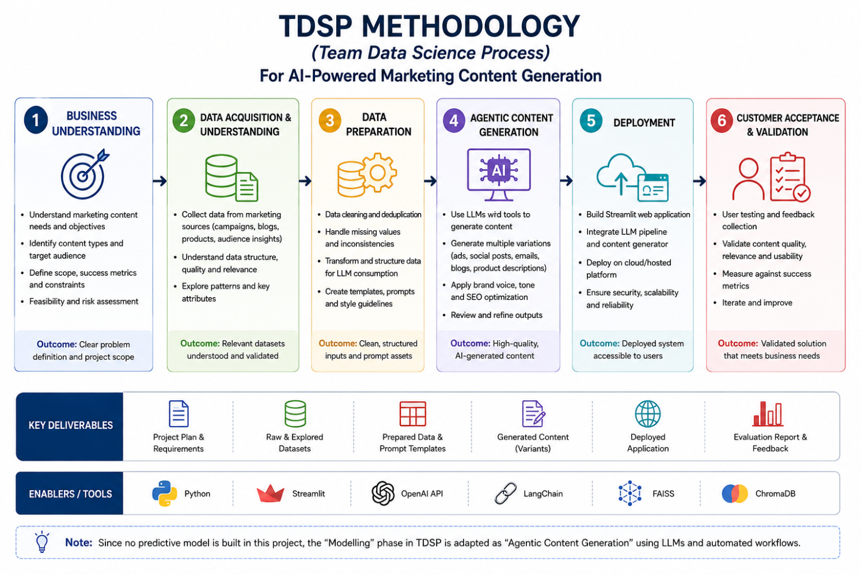
Fig 5.1. TSDP Methodology
5.1 The Six Phases as Executed
- Business Understanding: Defined the reviewer-focused requirements and created the YAML brand definition containing voice, restrictions, personas, compliance rules, and visual guidelines.
- Data Acquisition & Understanding:Retrieved three Shopify products through their public JSON data and examined their specifications, variants, prices, descriptions, and product images.
- Data Preparation: : Separated specifications from descriptions, selected the cheapest available variant, preserved image references, and created the grounded product-data prompt section.
- Agentic Content Generation: Implemented five validated LLM agents in a nine-node LangGraph workflow, including parallel execution, narration synthesis, and deterministic video rendering.
- Deployment: Implemented the Streamlit dashboard, review page, SQLite-backed job queue, worker process, and immutable versioned output directories.
- Customer Acceptance & Validation: Implemented human approval/rejection with feedback and validated the system using a 174-test offline suite plus an end-to-end live Shopify product run.
5.2 Problems Encountered and Changes to the Approach
TDSP is iterative, and several decisions were revised after evidence contradicted the original plan. Each entry in Table 5.1 was driven by an observed failure.
Table 5.1: Problems Encountered and How the Approach Changed
Problem observed | Original approach | Revised approach and rationale
Model responses arrived wrapped in prose, fences, trailing commas, comments and invisible Unicode, breaking a plain json.loads. | Parse the response directly. | A four-stage extractor: keep only text blocks, strip wrappers and invisibles, take the first brace-balanced object with a string-aware scan, then three progressively destructive repairs.
The caption agent produced a 293-character first line against a 70-character limit, three attempts running, and the job failed. | Validate the model's self-reported Firstline field. | Derive the first line from the caption text up to its first newline, which is what the platform actually truncates, and rewrite the prompt to explain that newline placement matters more than the hook's wording.
Piper spoke the narration in 22.37 s against a script the validator computed at 22.90 s, so the planned scene timings no longer matched the audio. | Pad or trim the audio to the planned video length. | Rescale every scene by one factor derived from the real WAV duration, absorbing residual drift into the last scene. Padding freezes on a dead frame, trimming cuts off narration.
Rejecting a version over one weak hashtag regenerated, and re-billed, all five copy artefacts, and the caption came back different for no reason. | Regenerate everything on every rejection. | Scoped feedback with a dependency cascade, and byte-identical carry-forward of out-of-scope artefacts recorded as carried forward.

The mid-course corrections recorded above were not stylistic choices but responses to specific failures encountered while working through each phase, from how the brand rules were represented to how narration was timed against video. Each was driven by evidence rather than preference, and the resource footprint and architecture they eventually settled on are what the next two chapters describe.

Chapter 6: Resource Requirement Specification
The system was designed to minimize external dependencies and run on a standard Windows laptop without requiring a GPU. The resource requirements cover the hardware, software libraries, external APIs and configuration needed to generate and validate the marketing content package.
6.1 Hardware Requirements
Table 6.1 Hardware Requirements
Component | Minimum Requirement | Recommended Requirement
Processor | 4 CPU cores | 4+ CPU cores
RAM | 8 GB | 16 GB
Storage | ~5 MB per generated version | 10 GB+ available
GPU | Not required | Not required
Internet | Broadband connection | Stable broadband connection
Operating System | Windows / Linux / macOS | Windows 10/11
6.2 Software Requirements
Table 6.2 Software Requirements
Layer | Software / Package | Version | Purpose
Programming | Python | 3.10+ | Application development
Configuration | python-dotenv | 1.0.1 | Environment variable management
Brand Definition | PyYAML | 6.0.3 | Brand configuration
Orchestration | LangGraph | 1.2.10 | Agent and state-graph orchestration
LLM | langchain-openai | 1.4.1 | OpenAI integration
LLM | langchain-google-genai | 4.3.2 | Gemini integration
LLM | langchain-anthropic | 1.5.4 | Anthropic integration
Video | MoviePy | 2.2.1 | Video processing
Video | imageio-ffmpeg | 0.6.0 | Video encoding
Image Processing | Pillow | 10.4.0 | Frame composition and text rendering
Numerical Processing | NumPy | 2.5.1 | Image and frame processing
Voice Generation | ElevenLabs | 1.58.0 | Hosted voice generation
Voice Fallback | Piper TTS | 1.3.0 | Local offline voice generation
Testing | pytest | 8.3.3 | Automated testing
Storage | SQLite | Built-in | State storage and job queue
6.3 API and Configuration Requirements
The system requires an external LLM API for content generation. The provider is selected through the LLM_PROVIDER setting, allowing OpenAI, Gemini or Anthropic models to be used without changing the main pipeline. API keys are stored in the .env file and are not committed to the project repository.
ElevenLabs API is used for voice generation when an API key and voice ID are available. If the ElevenLabs service is unavailable or the API call fails, the system falls back to Piper TTS, which performs local offline voice generation without requiring an external API. This ensures that narration can still be generated without interrupting the complete pipeline.
The main configuration parameters control LLM token limits, timeouts, retries, JSON-generation attempts, worker polling, video aspect ratio, frame rate, rendering threads and text-to-speech engine selection.
6.4 Data Requirements
The system does not require a training dataset or labelled corpus. Product information is obtained at run time from the public Shopify product page and its associated product data. The scraped product record is treated as the authoritative source for factual claims used in the generated content.
Table 6.3 Data requirements
API / Service | Requirement | Purpose | Fallback
LLM API | Required | Content generation through OpenAI, Gemini or Anthropic | None; run fails if valid output cannot be generated
ElevenLabs API | Optional | Neural voice generation | Piper TTS
Piper TTS | Local | Offline voice generation | pyttsx3, if configured
Shopify Product Endpoint | Required | Product details and specifications | None
Shopify CDN | Required when images are used | Product image retrieval | None
None of these requirements assumes anything the system cannot fall back from: no dataset needs to be labelled because product facts are read at run time rather than trained on, no voice engine is mandatory because a hosted service can hand off to an offline one, and no single LLM vendor is load bearing because the provider is a configuration choice, not a code path. These constraints, ordinary hardware, a swappable model provider, and graceful degradation wherever an external service could otherwise become a single point of failure, are what Chapter 7 designed the architecture around.

Chapter 7: Software Design
This chapter addresses Objective 1, presenting the architecture at three static levels, process topology, pipeline structure and data model, and then the dynamic views. Every decision descends from the governing rule of 5.1: a reviewer must never be shown something misleading.
7.1 Architectural Overview
The system is organized as three concerns sharing one state store, shown in Fig. 7.1. The presentation layer queues work and displays results, SQLite holds all state and is simultaneously the job queue, the execution layer owns the pipeline. The separation is the load-bearing decision: the interface stays responsive during a two-minute render because it is not doing the render, and the worker can be moved to another machine because the two communicate only through the database.
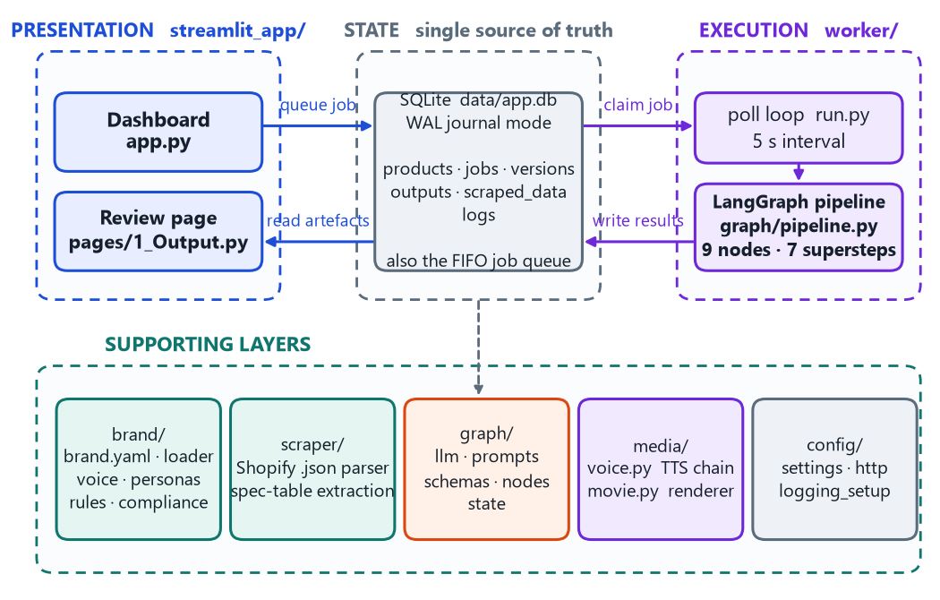
Fig. 7.1: Layered Architecture
7.2 The Pipeline Graph
The generation pipeline is a compiled LangGraph state graph [16] of nine nodes, shown in Fig. 7.2. Execution proceeds in supersteps: all nodes whose predecessors have completed are dispatched together, their partial states are merged, and the next superstep begins. The graph is acyclic, of fixed depth seven.
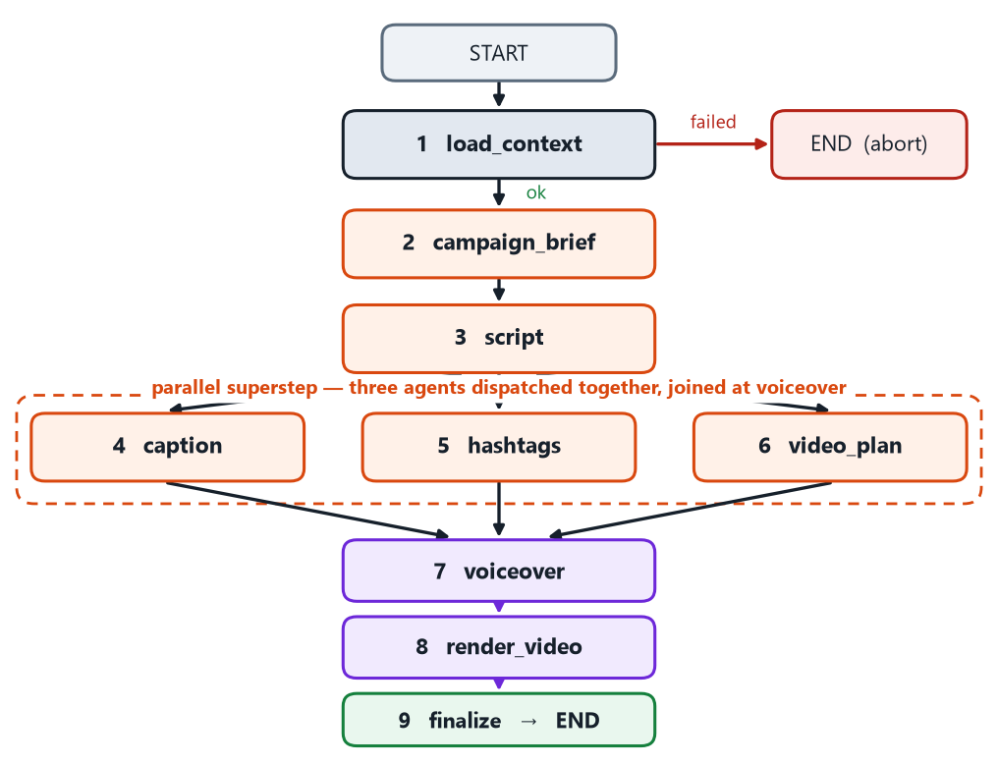
Fig. 7.2: The Nine-Node Pipeline Graph
The fan-out is real parallelism, safe by construction. The three branch agents read the brief and the script and write only their own state key, and the three keys they share carry explicit reducers, so LangGraph merges concurrent writes deterministically, without them the graph would silently lose two of every three artefact entries. There is exactly one conditional edge, gating the single condition that makes generation impossible: a product with no scraped data. Every node is wrapped by a tracker that records the stage and checks the cancellation flag on entry, so cancellation lands at a node boundary rather than midway through writing a file.
7.3 Data Flow
Fig. 7.3 is the level-1 data-flow diagram: three external entities, five processes and three data stores. It makes explicit the property the design turns on, that product facts enter the system exactly once, through P2, and every downstream process reads them from the store rather than from the network. The brand definition D3 reaches both the copy and media processes, which keeps the words an agent writes and the colors the renderer paints derived from the same authority.
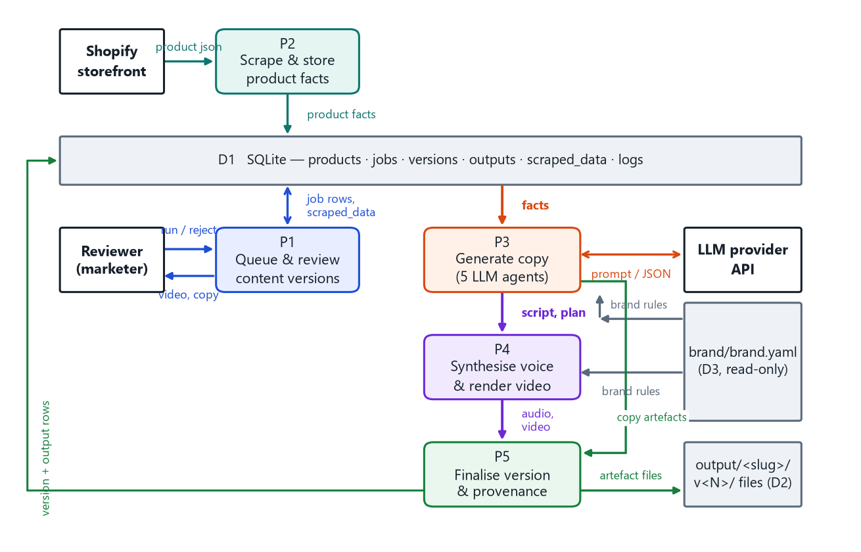
Fig. 7.3: Level-1 Data-Flow Diagram.
7.4 Data Model
Six tables hold all state, shown in Fig. 7.4, with status values enumerated by SQL CHECK constraints rather than in application code. Three constraints encode correctness properties: UNIQUE (products.url) makes seeding idempotent, UNIQUE (product_id, version_number) makes a version immutable, and versions.job_id is ON DELETE SET NULL while every other foreign key cascades, because deleting a job's history must not delete the version it produced.
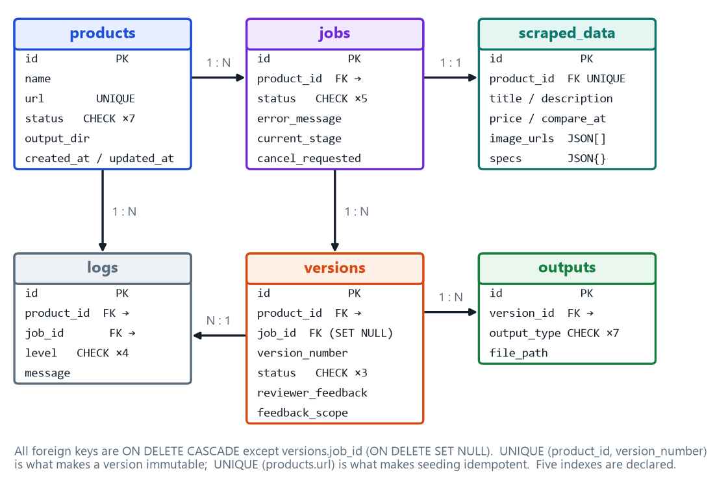
Fig. 7.4: Entity–Relationship Model.
The most consequential decision is invisible in the diagram: the version row is created last. The pipeline reserves the next version number without inserting a row, lays out the v<N>/ directory, writes every artefact into it, and only then inserts the version row. A version row is a promise that there is something to review, so making it the last write means a run that dies part way through leaves files on disk but no empty version staring at a reviewer.
7.5 Request Lifecycle and Job State Model
Fig. 7.5 traces a run from the reviewer's click to the reviewer's decision, making visible where the retry loop sits and how the interface learns the run has finished. Configuration is checked before the scrape, because scraping first and then discovering there is no usable API key wastes a request and reports the failure against the wrong stage.
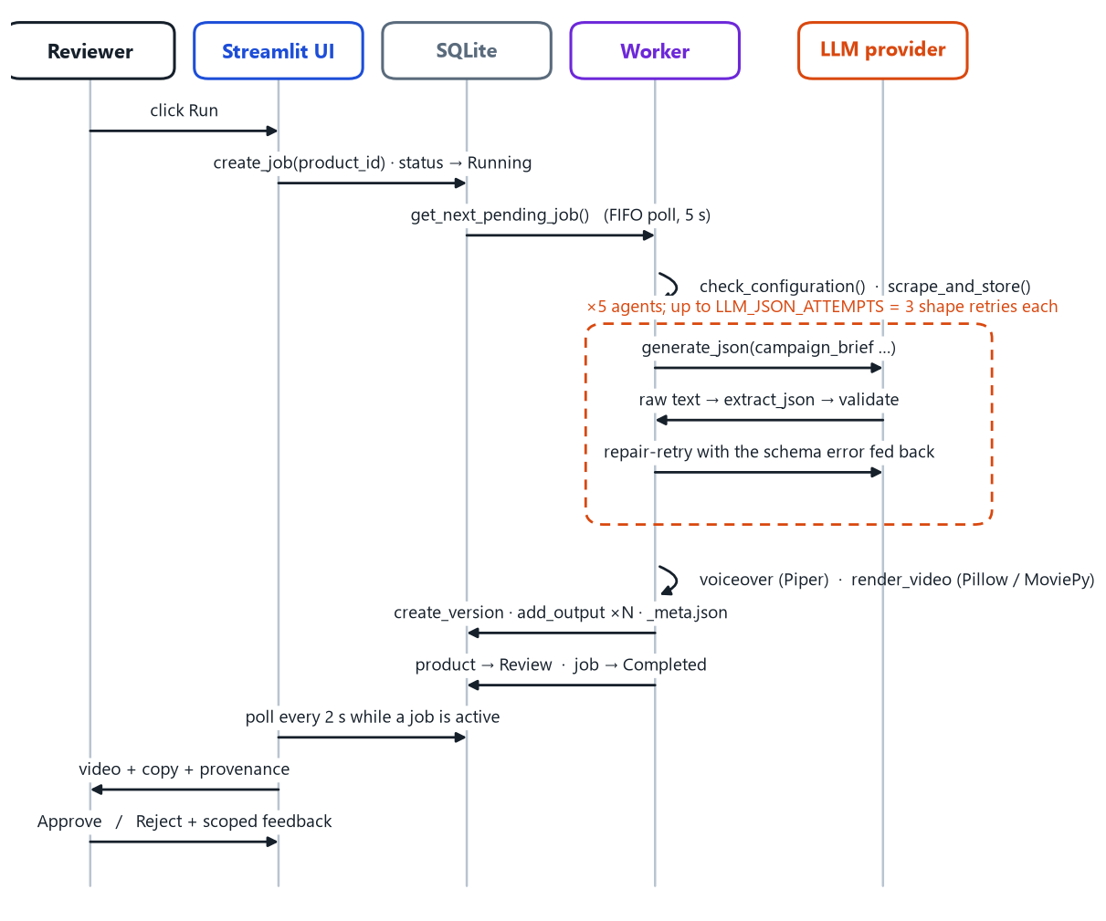
Fig. 7.5: Request Lifecycle.
A job reaches one of four terminal states from Running, and the product's status mirrors it with a Review state added before the reviewer's decision. One guarantee matters operationally: a job can only be Running while a live worker holds it in memory, so a worker that starts up and finds one knows the previous process died. Reclaiming those jobs prevents the active-job count from being permanently non-zero.

7.6 Brand as Data
Fig. 7.6 shows the dependency that makes the system re-targetable: a single YAML document is the authority for what agents may say, what validators enforce and what the renderer draws. There is no hard-coded colour value, tone rule or numeric content limit anywhere in the Python. The consequence was observed during this project: tightening the brand's script-duration window changed what the validator accepts with no code change and, as §9.3 reports, immediately broke three tests written against the previous window — corrected by updating the affected fixture to the new window.
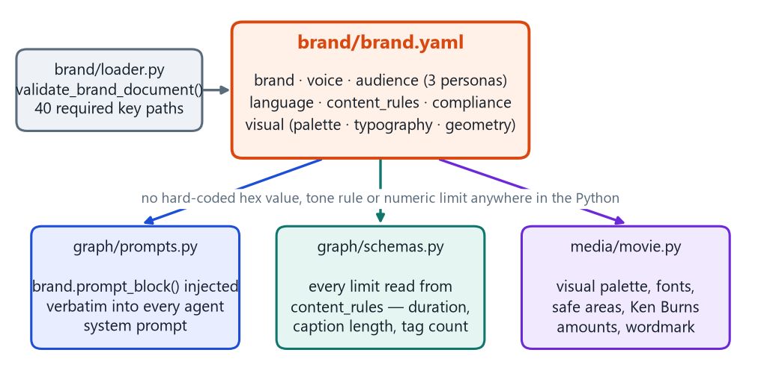
Fig. 7.6: The brand definition as the single authority for prompts, validation limits and rendered visuals
7.7 Design Decisions and Rationale
Table 7.1: Design Decisions and the Alternatives Rejected
Decision | Alternative considered | Why the alternative was rejected
LangGraph state graph with a fixed topology | A hand-written sequential function, or a conversational multi-agent framework [14] | The three-way fan-out is a real parallel superstep, hand-rolling it means writing thread coordination and merge logic. A conversational framework makes the number of billed model calls emergent.
SQLite as both state store and queue [28] | PostgreSQL with Redis or Celery | Single-machine deployment, the required semantics fit in six tables, and WAL mode makes concurrent thread access safe without a broker.
Deterministic renderer over still photography, with Pillow for all text | Generative video synthesis [18], MoviePy's TextClip | A diffusion model asked for a specific product produces a plausible-looking item, not that one, and the authoritative product photography already exists. TextClip shells out to ImageMagick, a classic deployment failure.
Fail the run rather than emit fallback copy | Return a template or a cached response on failure | A fallback is indistinguishable from real output at the point where a human approves it. This is the governing rule of the whole design.

The graph topology, the data model and the brand-as-data mechanism are, so far, a design on paper, decisions justified by the single governing rule that a reviewer must never be shown something misleading. Chapter 8 reports how each of them was built, and how that rule was carried down into working code rather than left as an architectural intention.

Chapter 8: Implementation
This chapter is organised to match Chapter 4: 8.1 implements Objective 2, 8.2 Objective 3 and 8.3 Objective 6. Objective 1 is addressed in Chapter 7. The delivered system is 6,488 lines of application Python.
8.1 Objective 2: Scraping, Data Layer, Agents and Media
To build the end-to-end generation pipeline, scraper, persistence, five LLM agents, speech synthesis and a deterministic renderer, with every brand rule externalized into a single machine-readable file.
8.1.1 Scraper, Data Layer and Prompt Construction
The scraper is 139 lines because it exploits the public JSON representation of a product page [5] rather than parsing rendered HTML. Two of its decisions are correctness decisions: every <table> in the description body is parsed into key/value pairs and then removed before the prose is extracted, so the description handed to the model does not repeat the specification rows, and among priced variants, available ones are preferred and the cheapest chosen. A malformed price becomes None with a warning, but a fetch failure or a missing product object raises. Facts may be absent, they may not be invented.
Every agent's system prompt is assembled by one function. The brand block is rendered from the YAML document and injected verbatim, but only the sections an agent can act on. The user message carries the fact block, the task and a # JSON KEYS section that must correspond precisely to the matching validator, because a response the prompt asks for but the validator rejects would loop until the attempt budget is exhausted.
Table 8.1: The Five Generation Agents
Agent | Role given to the model | Context | Key constraints enforced by its validator
campaign_brief | Senior performance marketing strategist | Fact block | Exactly one persona chosen from the brand's three ids, at least three proof points, each naming the scraped spec, price or description line it came from
script | Short-form video copywriter | Fact block + brief | Exactly five beats in the order hook, problem, product_reveal, proof, cta, hook ≤ 12 words, spoken length recomputed from word count and required to land in the brand's 32–40 s window
caption | Social copywriter | Fact block + brief + script | ≤ 300 characters, derived first line ≤ 70 characters, a call to action, no hashtags inside the caption
hashtags | Social strategist | Fact block + brief | 8–12 lowercase tags, the brand's mandatory tag always inserted first, five named tags banned, duplicates dropped
video_plan | Short-form video director | Fact block + script | 5–7 scenes, one per beat, in beat order, first scene title and last cta, every scene names a valid image index, spec pills copied verbatim from the scraped specs

8.1.2 Graph Assembly, Speech Synthesis and Video Rendering
The topology of Fig. 7.2 is twelve lines of graph construction, of which the loop is what creates the parallel superstep. Concurrent writes are made safe by reducers on the shared state: keys written by one node use last-write-wins, while the three accumulator keys carry explicit merge functions. There is deliberately no per-node error field, because a copy node either produces valid content or raises.
Narration comes from an ordered chain of engines, the first producing a valid WAV winning: Eleven Labs, a hosted neural voice reached through its API and needing a key, then Piper, a local VITS-derived ONNX neural voice [21], needing no key and no network, then pyttsx3. An engine synthesizes to a .partial.wav path and the file is moved into place only once it exists, is non-empty and yields a readable duration, so a half-written file can never be picked up as real audio.
The renderer is the largest module at 1,074 lines, and four commitments shape it: everything visual is read from the brand file, the whole video is one VideoClip with a hand-written frame function, all text is drawn with Pillow, and per-scene work is done once, so each frame only crops, resizes and alpha-composites. The product is lifted off its studio backdrop by a border-seeded flood fill rather than a global white threshold.
Retiming the scenes to the real narration is the most subtle correctness fix. The shot plan's durations are only an estimate from a words-per-second heuristic, and in the validated run the script measured 22.90 s while Piper spoke it in 22.37 s [27]. Padding the audio freezes the last frame on silence and trimming it cuts off narration, so every scene is instead rescaled by a single factor derived from the WAV header.
8.2 Objective 3: Fact Grounding and Validation
To implement hard-fact prompting, hardened JSON extraction, brand-derived schema validation with an explicit normalise-versus-reject split, an error-fed repair-retry loop, and a no-fallback rule. The hard-fact rule is a fixed block in every system prompt, telling the model that the scraped product data is its only source of product facts and that a missing fact must be written around, never estimated.
8.2.1 Hardened JSON extraction
Models are asked to return a single JSON object and frequently do not. The responses that had to be handled included objects wrapped in prose or markdown fences, trailing commas, comments, curly quotation marks used as delimiters, zero-width Unicode, a single-element array wrapping the object, and, from reasoning models, text interleaved with thinking blocks.
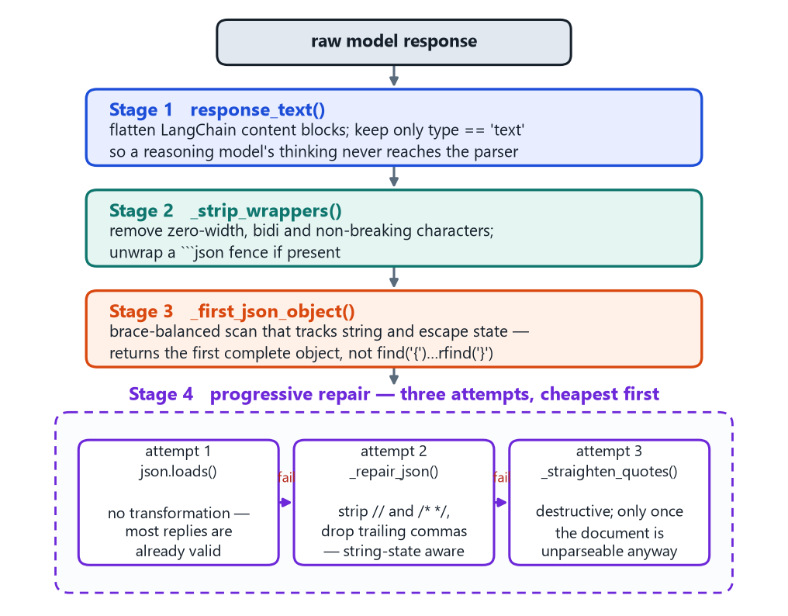
Fig. 8.1: The Four-Stage JSON Extraction and Repair Pipeline.
Stage one keeps only content blocks whose type is text, since concatenating everything would drop a reasoning model's chain of thought into the parser. Stage three is the piece most implementations get wrong: the obvious slice from the first { to the last } breaks on an object followed by prose containing a brace, and on two objects in a row. The scanner below returns the first brace-balanced object instead.
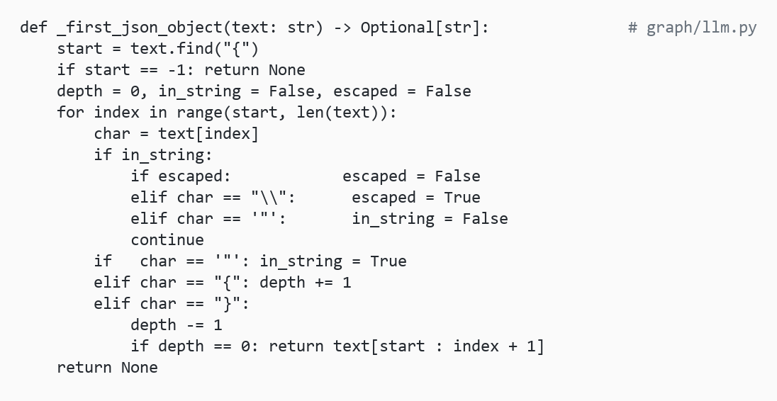
Fig. 8.2: The Code Snippet _first_json_object Brace-Scanner
Snippet in Fig 8.2 - first_json_object shows Extraction of the first complete, brace-balanced JSON object from a text string, ignoring braces inside quoted strings.
Steps:
- Locate the first { in the text.
- Walk through characters, tracking whether inside a string (so braces in quoted text are ignored) and whether the current character is escaped.
- Increase a depth counter on each {, decrease it on each }.
- When depth hits 0, return the substring from the first { to that closing } — a complete, balanced JSON object.
- If no balanced object is found, return None.

8.2.2 Brand-derived validators and the normalize/reject split
Each agent has a validator returning a normalized copy of the payload or raising with a message phrased as an instruction rather than as a diagnostic, so it can be handed straight back to the model. The decision that defines the module is the split in Table 8.2 between what the code fixes and what only the model can fix.
Table 8.2: What Is Normalized Locally Versus What is Rejected and Re-Asked
Bucket | Rule | Examples observed
Normalized | Anything the code can fix correctly and unambiguously | A hashtag missing its #,”Ride To Work!" becomes #ridetowork, an image index past the end of the list is wrapped modulo the count, "4.5 seconds" is parsed to 4.5, an unknown scene kind becomes feature, a bare-string proof point becomes {claim, source: "unattributed"}
Reject and re-ask | Anything requiring judgement | A persona id that does not exist in the brand file, a caption over 300 characters, a derived first line over 70, a script whose recomputed spoken length falls outside the brand's window, wrong or duplicated beat names, a shot plan not opening on a title card or closing on a call to action
Every limit is read from the brand file, so tightening a brand rule tightens validation with no code change. The most consequential validator is the script's: it discards the model's duration estimate and recomputes the spoken length from the word count, because the estimate is a guess whereas the word count is a fact, and that duration is what the video timeline is built from. The words-per-second constant used for this calculation, 2.4 (144 words per minute), was calibrated empirically against this project's Piper and ElevenLabs narration output during development rather than taken from a published source. This falls within the commonly reported range for narration and audiobook delivery, roughly 130–160 words per minute.
8.2.3 The Repair-Retry Loop and the No-Fallback Rule
On a schema error the model's own bad output is appended to the conversation, followed by a correction quoting the specific violation, and the call is repeated up to the configured budget.
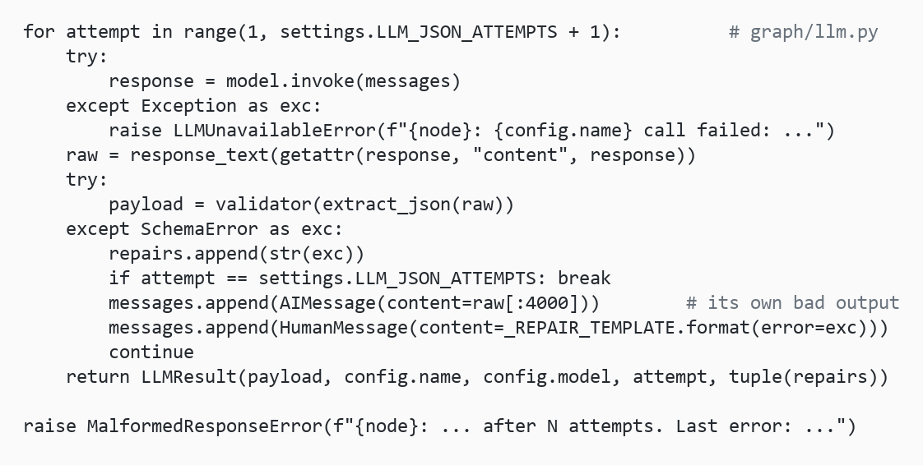
Fig 8.3: Code Snippet of the Repair-Retry Loop
Code Snippet in Fig 8.3 shows Repair-retry loop Retries an LLM call with error-specific correction prompts until it returns schema-valid JSON or the attempt budget is exhausted.
Steps:
- Call the model to get a response.
- Parse and validate the response as JSON against a schema.
- If invalid, append the bad output and a correction message to the conversation and retry.
- Repeat until valid output is returned or the attempt limit is reached.
- Return the valid result, or raise an error with the last failure reason if all attempts fail.
Transport retries for connection resets and HTTP 429 or 5xx are performed by the provider client, this loop performs only shape retries, because re-asking a dead endpoint merely delays the failure. If the budget is exhausted the job fails with the last schema error attached. There is no canned copy anywhere in the codebase to fall back to, asserted mechanically by test_never_substitutes_content_on_failure. One exception is reasoned rather than expedient: a video render failure produces a version anyway, because the copy is real and reviewable without the MP4.
Table 8.3: Failure Taxonomy and System Response
Condition | Response | Where handled
Missing or placeholder API key | Red banner on the dashboard, runs fail immediately naming the exact setting | check_configuration()
Provider quota exhausted (429) or model unavailable (404) | Transport retries, then the job fails with the provider's message preserved | provider client, generate_json()
Unparseable text, or valid JSON of the wrong shape | Retried with the parse position or the specific schema violation quoted | extract_json(), graph/schemas.py
Still wrong after the attempt budget | Job and product Failed, last error shown in the interface, nothing substituted | generate_json()
Images unfetchable, no font found, or every speech engine fails | Warning appended, gradient or default font substituted for the visual only, correctly timed silent track plus a banner in the review page | ImageLibrary, FontBook, media/voice.py
Video render fails | Version is still created, the copy is real and complete | nodes.render_video
Cancellation, a killed worker, or a run that dies before finalization | Honored at the next node boundary, or failed by the next start-up's reclamation, no version row, and the orphaned directory is removed | tracking wrapper, reclaim_stale_jobs()
Brand file missing a key / bad. env value | All problems reported at once at load, configuration error at import naming the variable | validate_brand_document(), config/settings.py

8.3 Implementation of Objective 6, Deployment and the Review Application
Objective 6: deploy the system as a demo-ready, single-command application with an embedded worker, a SQLite-backed queue, immutable versioned outputs, and a human approve/reject gate whose rejections carry scoped feedback.
8.3.1 Worker, Queue and Interface
The worker polls for the oldest pending job, transitions it to Running and processes it. The order of operations is chosen so a failure is reported against the stage that caused it: status transitions and a log row, a cancellation check, configuration validation, the scrape, then the pipeline. The transition to Completed sits inside the same try block as the pipeline call, so a failure there still resolves the job to Failed.
8.3.2 The Review Gate, Scoped Feedback and the Cascade
The review page presents the rendered video and its audio, the caption and hashtags side by side, an optional details panel with the brief, script, shot plan and provenance, and the approve/reject controls.
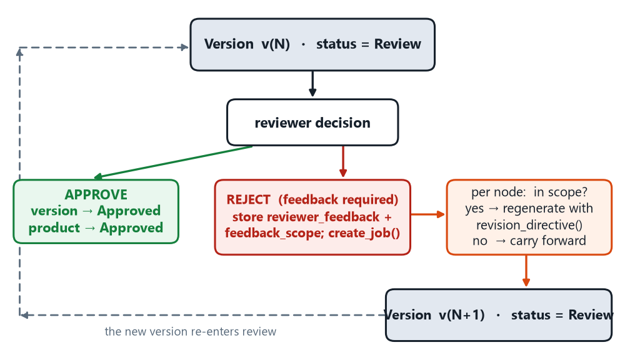
Fig. 8.4: The Human-In-The-Loop Review and Regeneration Loop.
Rejection requires written feedback, because feedback is what makes the next version different. The reviewer may scope it to the script, caption, hashtags or shot plan, the brief is not offered, because a viewer judging a finished video has no visibility into it. That scope is expanded through a dependency cascade: if a node is in scope, every node embedding its output in its own prompt must be too, otherwise the new version would pair a regenerated script with a caption written against the old one, output that is inconsistent, reads perfectly well, and is wrong.
The pipeline, the validation layer and the review application are now built. Chapter 9 reports how each was tested, and how the whole was validated end-to-end against a live product page.

Chapter 9: Testing and Validation
This chapter addresses Objectives 4 and 5. Section 9.1 states the requirements under test, 9.2–9.4 cover the automated suite including an honest account of three failing tests, and 9.5–9.7 report the end-to-end validation against a live product page, using measurements from the application's own log table, the provenance sidecar and the rendered media.
9.1 Requirements Testing
Table 9.1: Functional Requirements
ID | Functional requirement
FR1 | Register a public Shopify product URL as a product, rejecting duplicates and unusable URLs
FR2 | Scrape title, description, price, compare-at price, image URLs and the specification table from the product's JSON endpoint
FR3 | Persist one scraped record per product, upserted rather than duplicated
FR4 | Queue generation jobs first-in-first-out and process one at a time
FR5 | Generate a campaign brief naming exactly one valid persona and at least three proof points, each attributed to a scraped source
FR6 | Generate a five-beat script, in the brand's beat order, whose recomputed spoken duration lies inside the brand's window
FR7 | Generate a caption within the character and first-line limits, containing a call to action and no hashtags
FR8 | Generate 8–12 lowercase hashtags including the mandatory brand tag and excluding all banned tags
FR9 | Generate a 5–7 scene shot plan opening on a title card and closing on a call-to-action card, with valid image indices and verbatim specification pills
FR10 | Synthesise narration through a pluggable chain of engines, falling back to a correctly-timed silent track that is flagged to the reviewer
FR11 | Render a 1080×1920 H.264 video whose duration equals the synthesised narration duration
FR12 | Write every artefact into an immutable version directory and create the version row only after all of them exist
FR13 | Present the version for human approval with its provenance visible
FR14 | On rejection with feedback and a scope, regenerate in-scope nodes and carry the rest forward byte-identically
FR15 | Never substitute placeholder content, fail with a diagnosable message instead
FR16 | Change the model provider by configuration alone
FR17 | Honour a cancellation request at the next stage boundary
FR18 | Guarantee that every job reaches a terminal state, including after a worker crash
The non-functional requirements are reproducibility from pinned dependencies with no system-level installs, a suite that runs offline with no API key, an interface that stays responsive during a two-minute render, safe concurrent database access, failures that name their stage and cause, portability across Windows, Linux and macOS on CPU alone, and retargetability to another brand without code changes.
Automated Test Suite
The suite collects 174 tests across seven modules and runs in five seconds with no network and no API key: 38 in test_schemas.py covering each validator's accept, normalise and reject paths (FR5–FR9), 31 in test_scraper_and_brand.py covering parsing, variant selection, every scrape error path and the speech chain (FR1, FR2, FR10), 28 in test_repository.py covering CRUD, FIFO ordering, cascades and stale-job reclamation (FR1, FR3, FR4, FR12, FR18), 27 in test_llm_parsing.py (FR15), 25 in test_pipeline_logic.py covering scope expansion, carry-forward and retiming (FR11, FR14), 17 in test_generation.py (FR15, FR16), and 8 in test_ui.py (FR13).
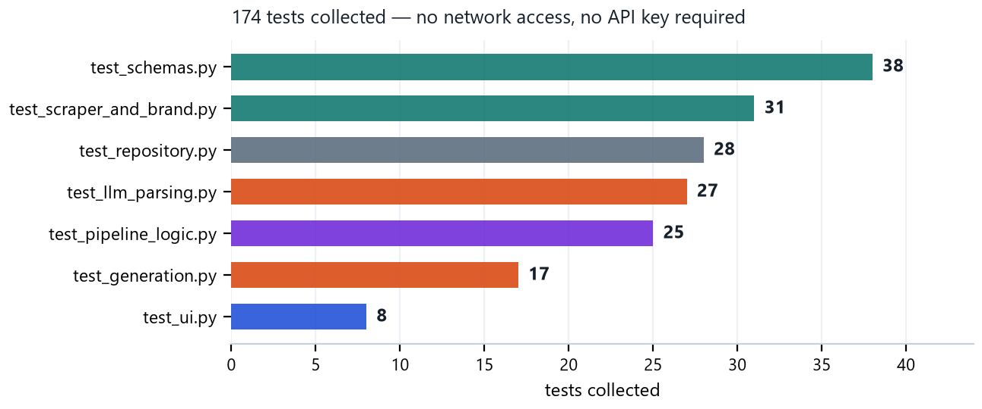
Fig. 9.1: Composition Of the Automated Test Suite, By Module.
Three choices change what the suite proves. The provider client is a scripted fake rather than a mock, so the retry and give-up logic is exercised directly, database tests run against a real temporary SQLite file, because the behaviour worth relying on lives in SQLite rather than in the Python wrapper, and schema tests run against the real brand file, because a synthetic brand would test the fixture rather than the rules.
9.3 Functional Test Cases and Results
The executed test cases covered key functional, validation, deployment, and live end-to-end behaviours of the system are:
Table 9.2: Functional Test Cases and Results
Test Case | FR | Description | Result
TC01 | FR1 | Duplicate URL — surfaced as "already exists"; no second row | Pass
TC03 | FR2 | Specification table removal — specifications stored separately from description text | Pass
TC04 | FR2 | First variant sold out — cheapest available variant selected | Pass
TC05 | FR3 | Re-scrape — existing product row overwritten rather than duplicated | Pass
TC06 | FR4 | Three queued jobs — oldest pending job returned first (FIFO) | Pass
TC08 | FR5 | Two proof points — rejected against the minimum of three | Pass
TC09 | FR6 | Script outside duration window — rejected with rewrite instruction | Pass
TC10 | FR6 | Inflated duration — duration recomputed from word count | Pass
TC11 | FR7 | First line over 70 characters — rejected based on actual text length | Pass
TC13 | FR9 | Out-of-range image index — wrapped modulo image count | Pass
TC14 | FR9 | Invalid opening title card — rejected with the relevant error | Pass
TC15 | FR10 | TTS engine failure — no partial WAV; fallback silent track generated | Pass
TC16 | FR11 | Narration shorter than plan — scenes rescaled to match audio duration | Pass
TC17 | FR14 | Script rejection — dependent caption, hashtags, and plan regenerated; brief carried forward | Pass
TC18 | FR14 | Hashtag rejection — four out-of-scope artefacts reused byte-identically | Pass
TC19 | FR14 | Multiple rejections — only the latest rejection drives the next run | Pass
TC21 | FR15 | Retry content — specific validation violation included in follow-up message | Pass
TC22 | FR16 | Placeholder key — treated as missing and error identifies the setting | Pass
TC23 | FR18 | Worker restart — orphaned job failed and active-job count returned to zero | Pass
TC24 | FR12, Live | End-to-end product run — ten files written and version row created last | Pass (9.5)
TC25 | FR11, Live | Audio/video synchronisation — rendered duration matched narration duration | Pass (9.6)
TC26 | FR5, Live | Claim traceability — every claim traced to specification, price, or description | Pass (9.6)
TC27 | FR15, Live | Caption exceeded limit after three attempts — job failed without creating a version or placeholder | Pass (9.5)

Overall: 27 executed test cases are recorded, all 27 Pass. TC10 initially failed because its test fixture used a duration value that predated a tightening of the brand's script-length rule; the fixture was corrected to generate a script whose recomputed duration lands inside the current window, and the test now passes. The full suite recorded 174 tests, all 174 passed (100%).
Table 9.3: Recorded Job Ledger for Product #4 (2026-08-06)
Job | Duration | Stage reached | Outcome and observed behaviour
1 | 18 s | campaign_brief | Failed. HTTP 429 RESOURCE_EXHAUSTED for gemini-2.5-pro. The provider's full quota message, including its suggested retry delay, was preserved in the job's error field. The scrape had already succeeded, so no product data was lost.
2 | 8 s | campaign_brief | Failed. HTTP 429 again. Failing at the first agent meant one billed call was attempted rather than five.
3 | 81 s | caption | Failed. The script agent needed 2 attempts, it returned eight beats including duplicates, was rejected with the expected and given sequences quoted, and recovered. The caption agent then produced a 293-character first line against the 70-character limit on all three attempts and the job failed. No version row was created and no placeholder caption was substituted (TC27).
4 | 5 s | campaign_brief | Failed. HTTP 404 NOT_FOUND reporting the configured model as unavailable. The same model completed successfully a minute later, so the condition was transient, the case demonstrates that the provider's own message reaches the interface verbatim rather than being replaced by a generic error.
5 | 214 s | finalize | Completed. Version v1 created with seven registered outputs and one recorded warning: the script agent needed 3 attempts, again for duplicated beats. Product moved to Review.
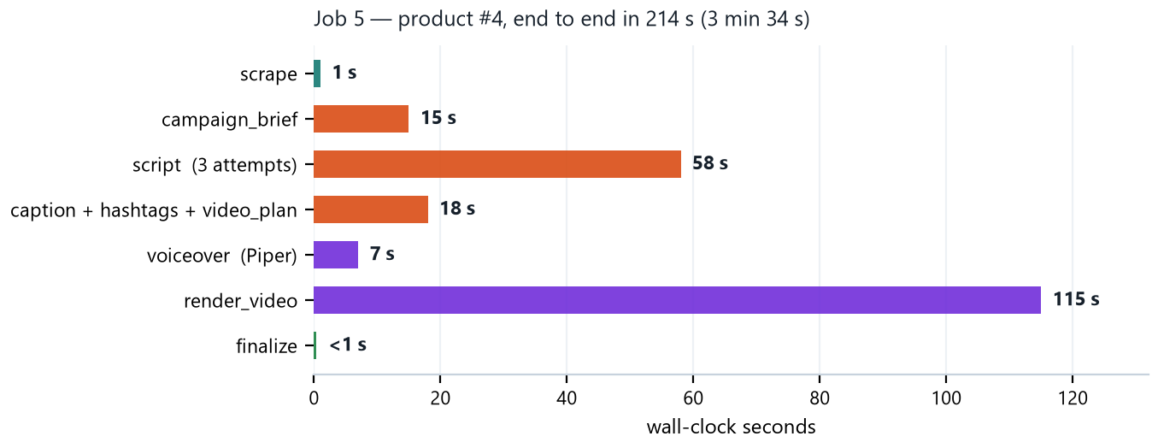
Fig. 9.2: Stage-Level Wall-Clock Timing for the Successful Run.
Three things in this profile are worth reading carefully. The video render dominates at 115 seconds, 54% of the total, expected for 671 frames of CPU compositing and H.264 encoding on a laptop. The script stage at 58 seconds is inflated by its two failed attempts, whereas the single-attempt brief took 15 seconds. And the parallel superstep is visibly doing its job, with three agents together taking 18 seconds.
9.6 Validation of the Generated Content and the Timing Chain
Version v1 comprises ten files totalling 4.7 MB: the brief and script as JSON and Markdown, the caption, the hashtag set, the video plan, a 986,668-byte voiceover.wav, a 3,714,755-byte 1080×1920 video.mp4 and the _meta.json sidecar. Seven output rows were registered and the version row was created after all of them. Table 9.4 is the claim-level check that matters for Objective 3.
Table 9.4: Traceability Of Every Factual Claim in Version V1
Claim as it appears in the output | Appears in | Source in the scraped record | Traceable
“a top speed of 30 km/h” | Brief, script, caption | Max Speed: 30 km/h specification row (also “up to 30km/h” in the description) | Yes
“up to 35 km on a single charge” | Brief, script, caption | Mileage: 30–35 km row (also “upwards of 30-35kms” in the description) | Yes
“14.5 kg” | Brief, script, caption | Weight of the Product: 14.5 kg row | Yes
“smaller than a carry-on bag” | Brief proof point | Present verbatim in the scraped description text | Yes
“₹75,000” | Script, caption, shot-plan CTA | price = 75000.0, the cheapest available variant | Yes
Specification pills on scene 4 | Rendered video frame | Max Speed, Mileage, Weight of the Product, label and value copied verbatim | Yes
“Range and speed vary.” | Script, caption, shot-plan CTA | The brand's compliance disclosure clause, required wherever a headline figure is the main claim | Yes (brand rule)
All three proof points in the brief carried an explicit source field, and no numeric claim appeared anywhere in the package that is not in the scraped record. Brand-rule conformance was likewise checked: the caption is 280 characters against a 300-character limit with a 57-character first line against a 70-character limit, and the hashtag set is 12 tags, all lowercase, with #radboards first and none of the five banned tags.
The timing chain is the clearest demonstration that the media layer is correct rather than approximately correct. The validator recomputed 55 words ÷ 2.4 words per second = 22.90 seconds and wrote that into the state, the shot-plan agent distributed the same 22.90 seconds across five scenes, Piper then spoke the joined lines in 22.37 seconds, measured from the WAV header. Rather than padding the audio, the renderer rescaled all five scenes by approximately 0.978, and the encoded MP4 reports 22.37 seconds.
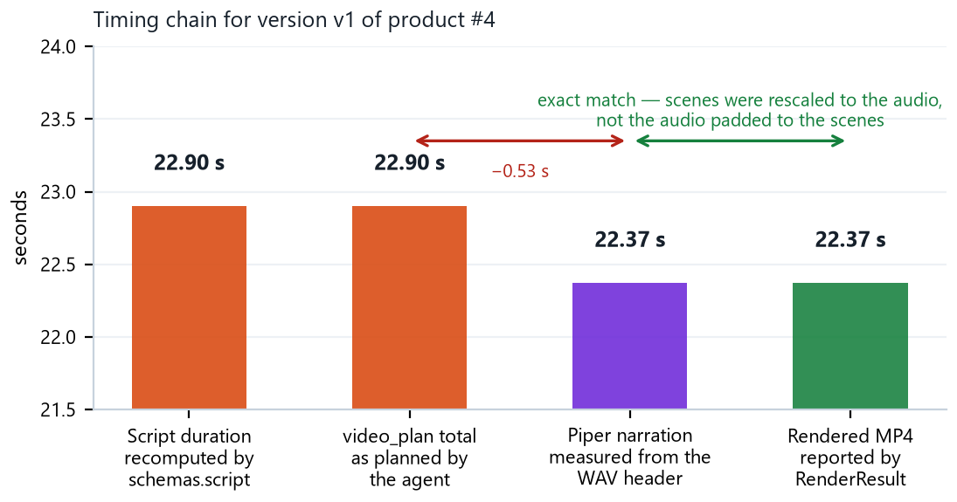
Fig. 9.3: The Timing Chain, From the Validator's Recomputed Script Duration to the Encoded MP4.
9.8 Estimated Resource Usage
Table 9.5 estimates the resource footprint of a successful run, all of which was accommodated within the free tiers of both the LLM provider and ElevenLabs during development and validation
Table 9.5: Estimated Resource Usage per Successful Run
Component | Calls / Units | Basis | Within free tier?
LLM calls (brief, script, 3 parallel agents) | ~7 calls per successful run | Estimated 800–1,200 input tokens and 200–400 output tokens per call, based on the brand block, fact block and task instructions each prompt carries | Yes — well inside Gemini's free-tier per-minute and daily quotas
ElevenLabs narration | ~400–500 credits per run | One narration per successful run, ~55-word script | Yes — free plan allows 10,000 credits/month, ≈20–25 runs

9.7 Validation of the Rendered Output and the Demonstration
Fig. 9.4 reproduces one frame from each of the five rendered scenes, sampled mid-scene so no frame is caught inside a cross-dissolve. These are frames from the actual video.mp4 produced by job 5, not mock-ups. Every element traces to a specific input: the headlines and sublines are the shot plan's fields, the three pills carry the specification labels and values verbatim, and the palette and typography are read from the brand file.
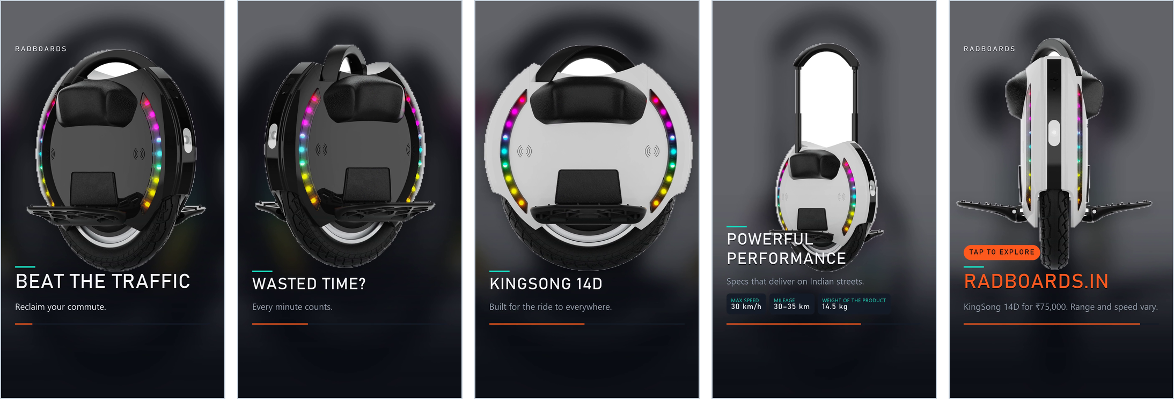
Fig. 9.4: Frames From the Five Scenes of the Rendered Video, Title, Two Feature Scenes, the Specification Scene and The Call-To-Action Card, Extracted from the Output MP4 .

For the demonstration the system runs from a single command, streamlit run streamlit_app/app.py, which starts the interface and the worker together. The demonstration follows the objectives: add a product URL (FR1), press Run and watch the progress bar (FR4, FR5–FR9), open the review page to play the video and inspect the provenance panel (FR11, FR13), then reject with feedback scoped to the hashtags and observe that the caption and shot plan come back byte-identical (FR14).
The test suite and the live run give the numbers. Chapter 10 maps them back onto the six objectives, one at a time.

Chapter 10: Analysis and Results
This chapter connects each result to the objective it validates, with the target stated and the measured outcome compared against it.
Objectives 1 and 2: Design and Build
Objective 1 targeted a state-graph topology with a defined parallel section, typed state with safe concurrent writes, a data model in which a version exists only when its artefacts do, and provider independence. All four were delivered and are evidenced in Chapter 7: nine nodes over seven supersteps with one conditional edge, a fan-out completing three agents in 18 seconds, and four failed runs in Table 9.3 that left no version row for a reviewer to open. Objective 1 was fully met.
For Objective 2, job 5 produced all eight artefacts from a single URL in 214 seconds. Externalization is verifiable rather than asserted: the brand file declares twelve content limits, the palette, two typeface roles, the safe areas, the Ken Burns amounts and the wordmark lock-up, and every one is read at run time. The clearest proof is negative: tightening one brand value changed validator behaviour with no code change, as 9.4 documents. Objective 2 was fully met.
Objective 3: Fact Grounding and Validation
On grounding, Table 9.4 records the outcome that matters: every factual claim in the package traces to a specification row, the scraped price or a phrase present verbatim in the description, and all three proof points named their source. Fig. 10.1 plots the attempts each agent needed across the two jobs that reached the fan-out.
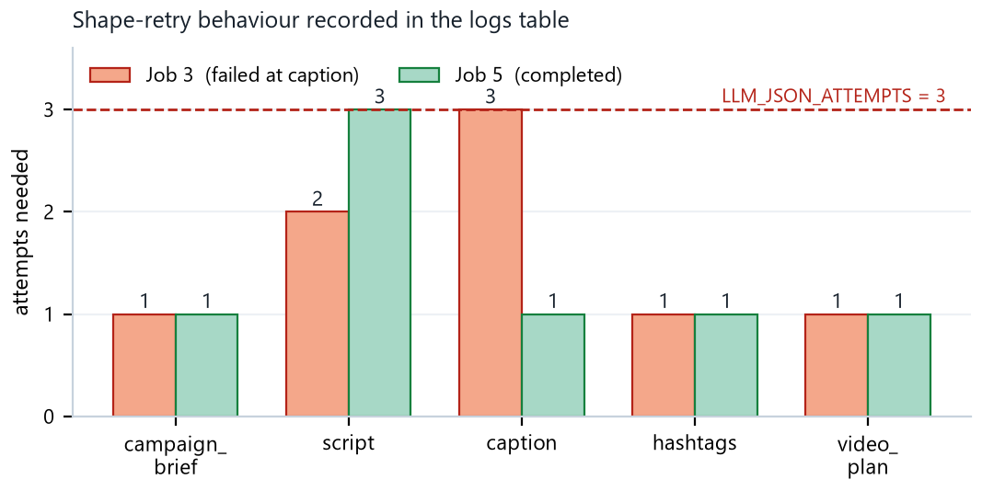
Fig. 10.1: Attempts Required Per Agent, From the Application's Log Table. The Dashed Line Is the Configured Budget.
The script agent violated the beat structure on both jobs, returning eight beats with proof and cta duplicated, and recovered on the second attempt in one case and the third in the other. On job 3 the caption agent exhausted all three attempts against the 70-character first-line limit and the run failed, a success for Objective 3, not a failure, because the alternative is what the no-fallback rule exists to prevent.
Two limits should be stated plainly. The observed sample is two jobs, so Fig. 10.1 characterises the mechanism rather than estimating a retry rate. More importantly, the system enforces structure and attribution discipline, not truth: nothing mechanically cross-checks a generated number against the specification dictionary, so a model writing “45 km range” for a 35 km product would pass every validator, leaving the hard-fact rule and the human gate as the mitigations. Objective 3 was fully met within the stated scope of structural rather than semantic verification.
Objectives 4, 5 And 6: Test, Validate And Deploy
The suite collects 174 tests, runs in 5.00 seconds with no network and no key, and covers all eighteen functional requirements of Table 9.1, twenty-seven test cases are recorded in Table 9.2. All 174 tests passed, a 100% pass rate. Three of these initially failed against a stale fixture that predated a tightening of the brand's script-length rule; the fixture was corrected before submission, and no production code was implicated. Objective 4 was fully met.
For Objective 5, all five measurements were taken: 214 seconds end to end with the render at 54%, the retry profile of Fig. 10.1, narration 22.37 s against a rendered MP4 of 22.37 s, a full provenance map, and five of five planned scenes rendered to plan. The scope should be stated honestly, one product, five jobs, one provider family and one reviewer, which characterises behaviour and failure modes but is not a statistical evaluation. Objective 5 was fully met at the stated scope.
For Objective 6, one command starts the interface and the worker together. Five products are registered, five jobs were processed, one version exists and is Approved, and its output directory has not been modified since it was written. The review gate, the mandatory-feedback rule, the scope checkboxes and the cascade are covered by TC17–TC19. One limitation is real and not hidden: the worker processes one job at a time. Objective 6 was fully met for a single-user deployment.
10.4 Consolidated Results
Table 10.1: Objectives, Targets and Measured Outcomes
Objective | Target | Measured outcome | Status
1, Design | Graph topology with a defined parallel section, safe concurrent state, version-row-last data model, provider independence | 9 nodes / 7 supersteps, 1 conditional edge, 3 reducers, 4 failed runs left 0 orphan version rows, 2 models used with no code change | Fully met
2, Build | All eight artefacts from one URL, every brand rule externalised | 8/8 artefacts in 214 s, 12 content limits, palette, typography and video geometry all read at run time | Fully met
3, Grounding | No unsupported claim reaches a reviewer, malformed output re-asked then failed | 7/7 claims traceable (Table 9.4), 3/3 proof points sourced, 2 structural violations corrected by retry, 1 job failed rather than publish an over-length caption | Fully met (structural)
4, Test | Offline suite covering every functional requirement, passing | 174 tests, 18/18 requirements covered, 27 test cases recorded, 174/174 pass | Fully met
5, Validate | Live measurement of latency, retries, synchronisation, provenance, fidelity | 214 s total, retry profile in Fig. 10.1, 22.37 s narration = 22.37 s video, full provenance map, 5/5 scenes rendered to plan | Fully met (1 product, 5 jobs)
6, Deploy | One-command demo with queue, immutable versions and scoped feedback | Single command starts interface and worker, FIFO queue, immutable v<N>/, cascade and carry-forward implemented and tested | Fully met (single user)

10.5 SWOT Analysis
Table 10.2: SWOT analysis of the delivery system
Strengths | Weaknesses
• No fallback content anywhere, a failure is visible rather than disguised.  • One brand file governs prompts, validators and rendered pixels at once, so the rules cannot drift apart.  • A fixed graph topology means the cost of a run is known before it starts.  • Provider-agnostic: three model families, switchable by one setting.  • Narration has a fully local, offline, free-at-the-margin fallback, so the pipeline is never dependent on a paid API to produce a usable track.  • 174 offline tests, the anti-hallucination guarantee is asserted mechanically.  • Scoped feedback avoids regenerating, and re-billing, accepted content. | • One worker, one job at a time, every Run button is disabled while a job is active.  • Shopify only, another platform needs a new scraper module.  • Three tests currently fail on a stale fixture (9.4).  • The brand file is cached for the process lifetime, so editing it needs a restart.  • English only, validation covers one product and five jobs.
Opportunities | Threats
• A claim-verification node cross-checking every number against the specification dictionary would close the one substantive gap in the grounding story.  • The renderer already supports square and landscape presets, producing all three aspect ratios per version is plumbing rather than design.  • An approved version contains everything needed to post through a platform API.  • Two caption or hashtag variants for the reviewer to choose between is a small change to an existing parallel superstep.  • The brand generator already retargets the system to any Shopify store. | • Model availability and pricing move under the system's feet, two of five recorded jobs failed on provider quota and one on a model withdrawal.  • Platform layout changes would invalidate the safe areas, though these live in the brand file rather than in code.  • Regulation of AI-generated advertising is developing, and the ASCI Code already places the substantiation burden on the advertiser [4].  • Widespread use of the same models risks homogenising brand voice across competitors, which is what the banned-vocabulary list exists to resist.  • Scraped third-party product descriptions are passed directly into LLM prompts; a malicious or compromised Shopify listing could embed prompt-injection text attempting to override brand rules or the hard-fact constraint, a risk not addressed by the current design

Every measured outcome has now been checked against its target, and the system's strengths have been set against its weaknesses. The final chapter draws conclusions from this evidence and recommends what should follow it.

Chapter 11: Conclusions and Recommendations for Future Work
This chapter draws conclusions from the evidence in Chapters 9 and 10, states what the system contributes and where it falls short, and closes with five recommendations, ordered by how much each would improve the system.
Conclusions
This project set out to establish whether a generative system can produce a complete short-form video marketing package from a single e-commerce product URL without introducing claims the product data does not support. On the evidence of Chapters 9 and 10, it can, provided the system is willing to fail.
All six objectives were addressed, Objectives 1, 2, 3, 5 and 6 were fully met and Objective 4 was partially met. Concretely: the system converted a live product URL into eight artefacts in 214 seconds (single measured run), including a 22.37-second video whose duration matches its narration exactly (also a single-run measurement) , all seven factual claims trace to a scraped specification row, the price or a phrase present verbatim in the description, all 174 tests pass across all eighteen functional requirements, and across five recorded jobs the system failed four times without once showing a reviewer content it had not really generated.
Objective 4 illustrates a secondary finding about the design. Three tests initially failed after the brand's script-duration window was tightened, because every validation limit is read from the brand file rather than compiled into Python, so changing one line of configuration immediately changed what the validator accepted — including inside the test suite. The affected fixture was updated to the new window and the suite now passes in full, but the episode is retained here as evidence of how tightly the brand file and the test suite are coupled by design.
The broader conclusion concerns the design stance rather than the numbers. Chapter 2 shows the literature treating grounding as a retrieval problem [9] or an evaluation problem [8], and output shape as a decoding problem [10]., [11] In a production pipeline built on hosted models neither framing is available: the source document is already known, and the token distribution is not. What remains is engineering, parse defensively, validate against limits derived from the same file the prompt was built from, return the violation to the model, and refuse to substitute anything when that does not work.

11.2 Contributions and Limitations
- A working end-to-end system converting one public Shopify product URL into eight reviewable marketing artefacts, including a rendered vertical video, on commodity hardware with no GPU.
- Brand-as-data governance in which a single machine-readable file simultaneously drives agent prompts, schema validation limits and rendered visual output, so a rule change propagates to all three without touching code.
- A no-fallback architecture in which the absence of placeholder content is a structural property asserted by a named test rather than a policy, and the single permitted degradation, a failed render, is argued for explicitly.
- Scoped feedback with a dependency cascade, modelling the reviewer response “this part is wrong, the rest is fine” by regenerating only the affected nodes and their dependents.
- A deterministic renderer whose scene timings are rescaled to the measured narration length rather than the reverse, together with a border-seeded flood-fill cut-out that survives products carrying white printed graphics.
Table 11.1: Limitations
Limitation | Detail and consequence
Claims are verified structurally, not semantically | The validators enforce persona validity, duration, length and count, not truth. A model writing “45 km range” for a 35 km product would pass every check and rely entirely on the human gate. This is the largest single gap and the first item in 11.3.
Single worker, one job at a time | The interface disables every Run button while any job is active. Correct for a demonstration, a shared deployment needs per-product locking and a job-claiming transaction.
Shopify only, English only | The scraper depends on the public product JSON endpoint, and prompts, brand definition and interface are English-only. Another platform needs a new scraper module, though nothing downstream would change.
Brand file cached | Editing the brand definition requires a restart of the process for the new rules to take effect; not observed to cause any other issue.
Validation scope, render cost | One product, five jobs, one provider family, one reviewer , enough to characterize behaviour and failure modes, not a basis for statistical claims. Rendering takes 115 seconds for a 22-second clip on a four-thread CPU.
No baseline comparison | The multi-agent, schema-validated pipeline is not compared against a simpler single-prompt-generates-everything baseline, so the marginal benefit of the added architecture is argued qualitatively rather than demonstrated quantitatively.
No content-quality / marketing-effectiveness evaluation | Success is defined entirely by structural conformance (schema validity, length limits, traceability of claims). No human-preference study, A/B test, or engagement measurement assesses whether the generated copy is persuasive or would perform in an actual campaign

Recommendations for Future Work
Ordered by how much they would improve the system.
- A claim-verification node. Extract every numeric token and unit from the brief, script and caption and cross-check each against the specification dictionary and the scraped price, failing the node with the unsupported figure quoted. This converts the central guarantee from “the model was told not to” into “the pipeline checked”.
- A brand-compliance critique pass. A node scoring its own output against the brand's banned-vocabulary and prohibited-claim lists and re-asking on a violation, in the manner of Self-Refine [17]. The recursion limit is already set explicitly to accommodate a cycle.
- Multi-worker operation. A job-claiming UPDATE … WHERE status='Pending' RETURNING transaction would allow several workers and remove the global Run lock.
- Direct publishing and all aspect ratios. The renderer already resolves square and landscape presets, and an approved version contains the video, the caption and the hashtags, which is everything a platform posting API needs.
- An evaluation study. Running the caption and hashtag branch twice at different temperatures would let the reviewer choose between variants, generating genuine preference data that an LLM-judge protocol in the manner of G-Eval [25] could use to assess copy quality at a scale the human gate cannot reach. This is deliberately last, worth pursuing only once the groundedness guarantee above is mechanical.
Taken together, these five recommendations describe the same trajectory as the project itself: moving a guarantee out of the prompt, where it is a request, and into code, where it is a check.

Bibliography
[1] M. H. Huang and R. T. Rust, “A strategic framework for artificial intelligence in marketing,” J. Acad. Mark. Sci., vol. 49, no. 1, pp. 30–50, Jan. 2021, doi: 10.1007/s11747-020-00749-9.
[2] D. Grewal, C. B. Satornino, T. Davenport, and A. Guha, “How generative AI Is shaping the future of marketing,” J. Acad. Mark. Sci., vol. 53, no. 3, pp. 702–722, May 2025, doi: 10.1007/s11747-024-01064-3.
[3] Q. Chen, J. Lin, Y. Zhang, H. Yang, J. Zhou, and J. Tang, “Towards knowledge-based personalized product description generation in E-commerce,” in Proceedings of the ACM SIGKDD International Conference on Knowledge Discovery and Data Mining, Association for Computing Machinery, Jul. 2019, pp. 3040–3050. doi: 10.1145/3292500.3330725.
[4] Advertising Standards Council of India, “The ASCI Code”.
[5] Shopify Inc., “Storefront API reference.”
[6] Z. Ji et al., “Survey of Hallucination in Natural Language Generation,” Jul. 2024, doi: 10.1145/3571730.
[7] J. Maynez, S. Narayan, B. Bohnet, and R. Mcdonald, “On Faithfulness and Factuality in Abstractive Summarization,” 1906. [Online]. Available: https://github.com/google-research-
[8] H. Rashkin et al., “Measuring Attribution in Natural Language Generation Models,” Aug. 2022, [Online]. Available: http://arxiv.org/abs/2112.12870
[9] P. Lewis et al., “Retrieval-Augmented Generation for Knowledge-Intensive NLP Tasks,” Apr. 2021, [Online]. Available: http://arxiv.org/abs/2005.11401
[10] B. T. Willard and R. Louf, “Efficient Guided Generation for Large Language Models,” Aug. 2023, [Online]. Available: http://arxiv.org/abs/2307.09702
[11] S. Geng, M. Josifoski, M. Peyrard, and R. West, “Grammar-Constrained Decoding for Structured NLP Tasks without Finetuning.” [Online]. Available: https://github.com/epfl-dlab/GCD.
[12] P. Liu, W. Yuan, J. Fu, Z. Jiang, H. Hayashi, and G. Neubig, “Pre-train, Prompt, and Predict: A Systematic Survey of Prompting Methods in Natural Language Processing,” Jul. 2021, [Online]. Available: http://arxiv.org/abs/2107.13586
[13] S. Yao et al., “ReAct: Synergizing Reasoning and Acting in Language Models,” Mar. 2023, [Online]. Available: http://arxiv.org/abs/2210.03629
[14] Q. Wu et al., “AutoGen: Enabling Next-Gen LLM Applications via Multi-Agent Conversation,” Oct. 2023, [Online]. Available: http://arxiv.org/abs/2308.08155
[15] T. Guo et al., “Large Language Model based Multi-Agents: A Survey of Progress and Challenges,” 2024.
[16] LangChain Inc., “LangGraph documentation.”
[17] A. Madaan et al., “Self-Refine: Iterative Refinement with Self-Feedback,” May 2023, [Online]. Available: http://arxiv.org/abs/2303.17651
[18] A. Blattmann et al., “Stable Video Diffusion: Scaling Latent Video Diffusion Models to Large Datasets,” Nov. 2023, [Online]. Available: http://arxiv.org/abs/2311.15127
[19] S. Niklaus, L. Mai, J. Yang, and F. Liu, “3D ken burns effect from a single image,” ACM Trans. Graph., vol. 38, no. 6, Nov. 2019, doi: 10.1145/3355089.3356528.
[20] J. Kim, J. Kong, and J. Son, “Conditional Variational Autoencoder with Adversarial Learning for End-to-End Text-to-Speech,” 2021. [Online]. Available: https://jaywalnut310.github.io/vits-demo/index.html
[21] Open Home Foundation, “Piper: A fast, local neural text-to-speech engine (GitHub)”.
[22] X. Wu, L. Xiao, Y. Sun, J. Zhang, T. Ma, and L. He, “A Survey of Human-in-the-loop for Machine Learning,” Apr. 2022, doi: 10.1016/j.future.2022.05.014.
[23] S. Amershi et al., “Guidelines for human-AI interaction,” in Conference on Human Factors in Computing Systems - Proceedings, Association for Computing Machinery, May 2019. doi: 10.1145/3290605.3300233.
[24] D. Sculley et al., “Hidden Technical Debt in Machine Learning Systems.”
[25] Y. Liu, D. Iter, Y. Xu, S. Wang, R. Xu, and C. Zhu, “G-EVAL: NLG Evaluation using GPT-4 with Better Human Alignment.” [Online]. Available: https://github.com/nlpyang/geval
[26] Microsoft Corporation, “Team Data Science Process: Lifecycle (GitHub)”.
[27] J. R. Williams, “Guidelines for the Use of Multimedia in Instruction,” 1998.

\

Appendix A: Repository, Setup and Entry Points

GitHub repository: https://github.com/Shyamsundarkanaka/AI-Powered-Marketing-

Environment setup and launch Sets up the Python environment, installs dependencies, configures secrets, seeds sample data, and launches the app.
Fig A.1: Environment setup
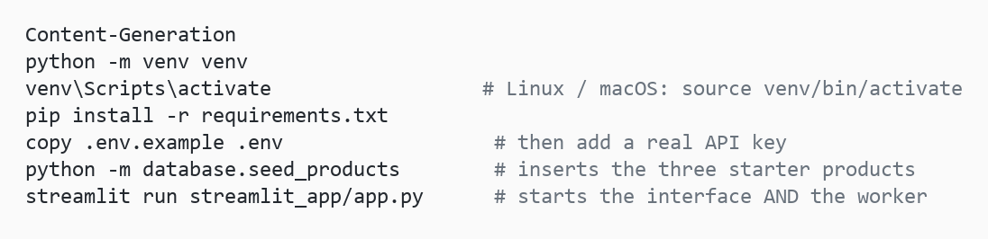

- python -m venv venv — create an isolated virtual environment.
- venv\Scripts\activate — activate it (Linux/macOS: source venv/bin/activate).
- pip install -r requirements.txt — install project dependencies.
- copy .env.example .env — create the environment file, then add a real API key.
- python -m database.seed_products — seed the database with the three starter products.
- streamlit run streamlit_app/app.py — launch the Streamlit interface, which also starts the background worker.

No system ffmpeg is required, imageio-ffmpeg bundles its own binary. Without a valid API key the dashboard shows a red banner and every run fails immediately naming the missing setting, rather than producing filler. Every component can also be exercised on its own.

Table A.1: Command-line entry points
Command | Effect
streamlit run streamlit_app/app.py | Dashboard and review page, with the worker on a background thread
python -m worker.run | Worker only, as a long-lived process , the production shape
python -m database.seed_products | Insert the three starter products (idempotent)
python -m database.reset [--yes] [--keep-cache] [--no-seed] | Destructive wipe and re-seed
python -m scraper.run --product-id N / --all | Re-scrape without generating
python -m graph.pipeline N | Run the full pipeline for one product, without the worker
python -m media.movie --plan path/to/video_plan.json | Re-render just the video , zero model calls
python -m media.voice --text "..." | Exercise the speech chain
python -m brand.generate <store-url> [--out DIR] | Regenerate the entire brand folder from a live Shopify store
pytest | Run the 174-test suite

Appendix B: Plagiarism Report
[TURNITIN REPORT TO BE INSERTED]

